PROGRAM1:Web Configuration File

Web Configuration File-1

<?xml version="1.0"?>

<!--

For more information on how to configure your ASP.NET application, please visit

http://go.microsoft.com/fwlink/?LinkId=169433

-->

<configuration>

<appSettings>

<add key="first" value="TRAIN PASSENGER DEATAILS"/>

</appSettings>

<system.web>

<compilation debug="true" targetFramework="4.5"/>

<httpRuntime targetFramework="4.5"/>

</system.web>

</configuration>

DEFAULT AXPX-1

<%@ Page Language="C#" AutoEventWireup="true" CodeFile="Default.aspx.cs" Inherits="_Default" %>

<!DOCTYPE html>

<html xmlns="http://www.w3.org/1999/xhtml">

<head runat="server">

<title></title>

</head>

<body>

<form id="form1" runat="server">

<div>

<asp:Label ID="Label1" runat="server" Text="<%$appSettings:first%>">"</asp:Label>

<br />

<br />

&nbsp;<asp:ImageButton ID="ImageButton1" runat="server" ImageUrl="~/train.jpg" PostBackUrl="~/second/Default.aspx" />

<br />

<br />

<br />

<br />

</div>

</form>

</body>

</html>

Design page-1

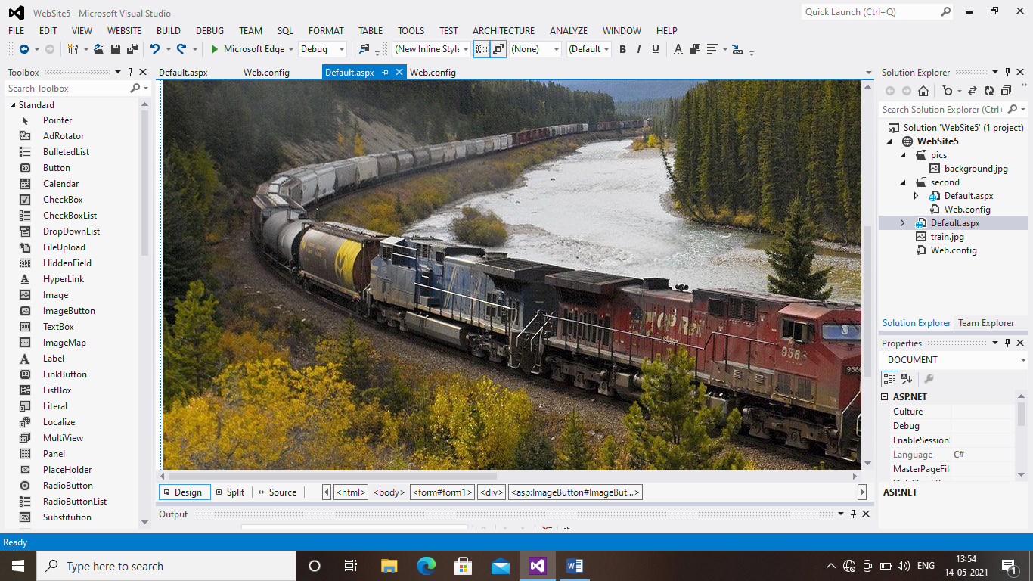

Web Configuration File-2

<?xml version="1.0"?>

<configuration>

<appSettings>

<add key="Name" value="deepthi"/>

<add key="From" value="New delhi"/>EZ

<add key="To" value="Chennai"/>

<add key="Date" value="10/08/2021"/>

<add key="Ticket type" value="e-Ticket"/>

<add key="Quota" value="General"/>

</appSettings>

<system.web>

</system.web>

</configuration>

DEFAULT AXPX-2

<%@ Page Language="C#" AutoEventWireup="true" CodeFile="Default.aspx.cs" Inherits="second_Default" MasterPageFile="" %>

<!DOCTYPE html>

<html xmlns="http://www.w3.org/1999/xhtml">

<head runat="server">

<title></title>

</head>

<body>

<form id="form1" runat="server">

<div>

Name:<asp:Label ID="Label1" runat="server" Text="<%$appSettings:Name%>">"</asp:Label>

<br />

From:<asp:Label ID="Label2" runat="server" Text="<%$appSettings:From%>"></asp:Label><br />

To:<asp:Label ID="Label3" runat="server" Text="<%$appSettings:To%>"></asp:Label><br />

Date:<asp:Label ID="Label4" runat="server" Text="<%$appSettings:Date%>"></asp:Label><br />

Ticket type:<asp:Label ID="Label5" runat="server" Text="<%$appSettings:Ticket type%>"></asp:Label><br />

Quota:<asp:Label ID="Label6" runat="server" Text="<%$appSettings:Quota%>"></asp:Label>&nbsp;&nbsp;&nbsp;&nbsp;&nbsp;&nbsp;&nbsp;&nbsp;&nbsp;&nbsp;&nbsp;&nbsp;&nbsp;&nbsp;&nbsp;&nbsp;&nbsp;&nbsp;&nbsp;&nbsp;&nbsp;&nbsp;&nbsp;

<br />

&nbsp;<asp:ImageButton ID="ImageButton1" runat="server" ImageUrl="~/pics/background.jpg" Width="257px" />

<br />

</div>

</form>

</body>

</html>

Design page-1

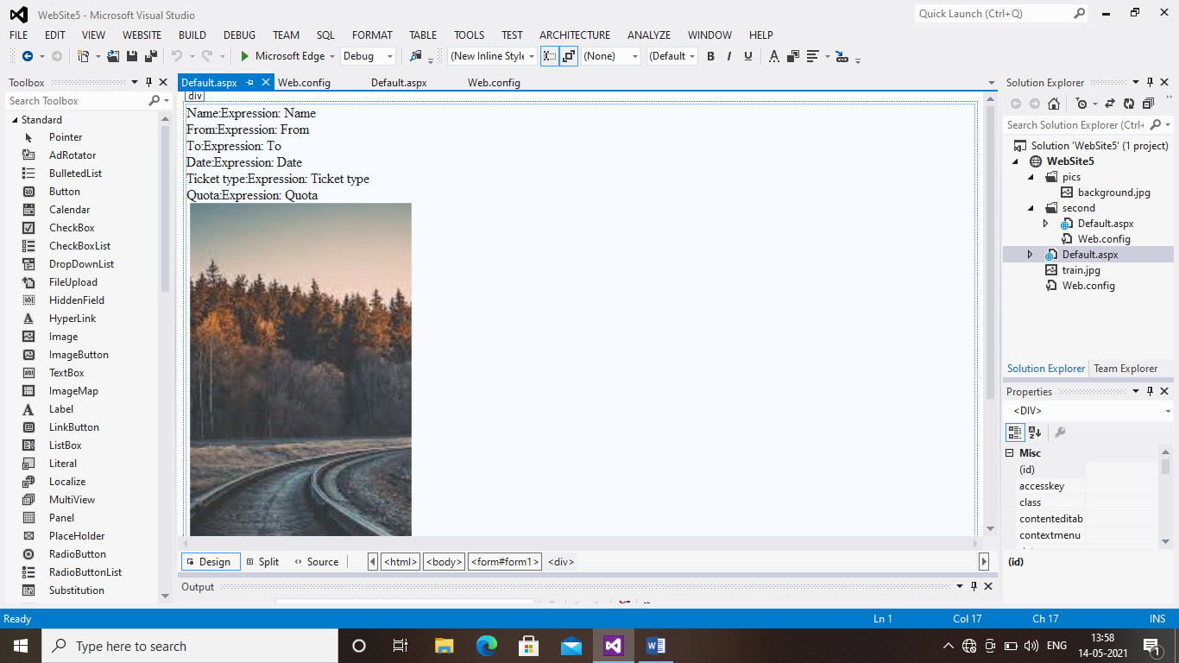

OUTPUT 1:

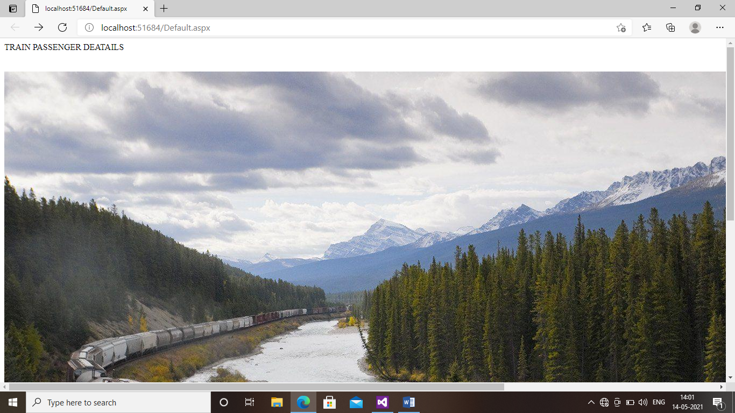

OUTPUT 2:

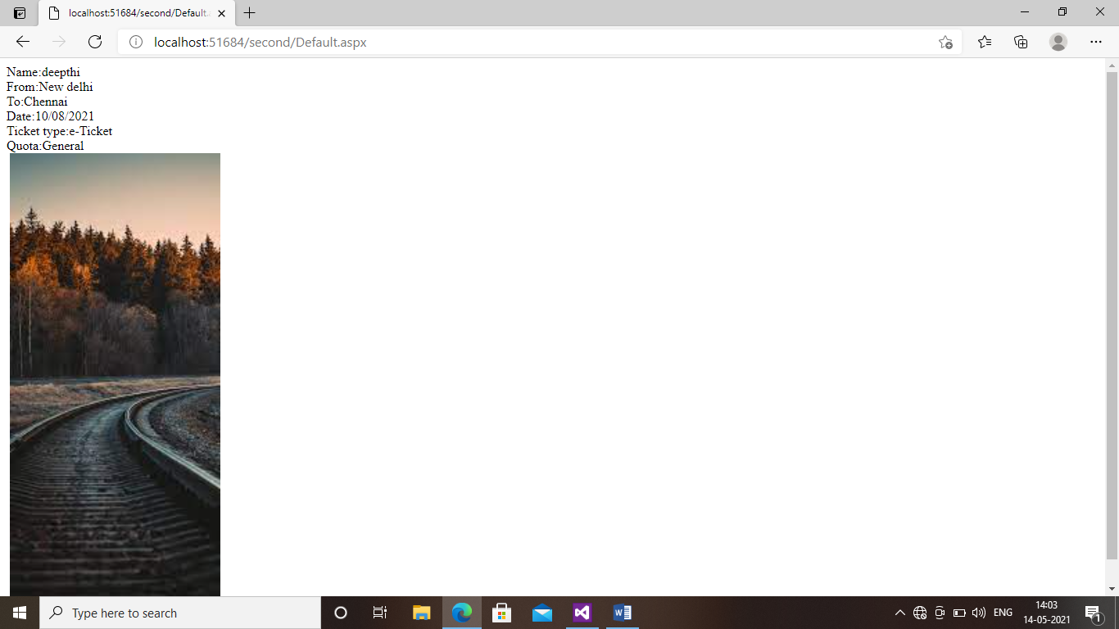

PROGRAM3:HTML SERVER CONTROLS

DEFAULT AXPX SOURCE CODE

<%@ Page Language="C#" AutoEventWireup="true" CodeFile="Default.aspx.cs" Inherits="_Default" %>

<!DOCTYPE html>

<html xmlns="http://www.w3.org/1999/xhtml">

<head runat="server">

<title></title>

</head>

<body>

<form id="form1" runat="server">

<div>

<h1>HTML SERVER CONTROLS

</h1>

<h2>InnerHTML</h2>

<br />

<table>

<tr>

<td>Name:</td>

<td>

<input type="text"

id="txtName"

runat="server" />

</td>

</tr>

<td>Street:</td>

<td>

<input type="text"

id="txtStreet"

runat="server" />

</td>

<tr>

<td>City:</td>

<td>

<input type="text"

id="txtCity"

runat="server" />

</td>

</tr>

<tr>

<td>State:</td>

<td>

<input type="text"

id="txtState"

runat="server" />

</td>

</tr>

<tr>

<td></td>

<td id="tdInnerHtml" runat="server" />

</tr>

</table>

<input type="submit" value="Do it!!" />

</div>

</form>

</body>

</html>

DESIGN PAGE:

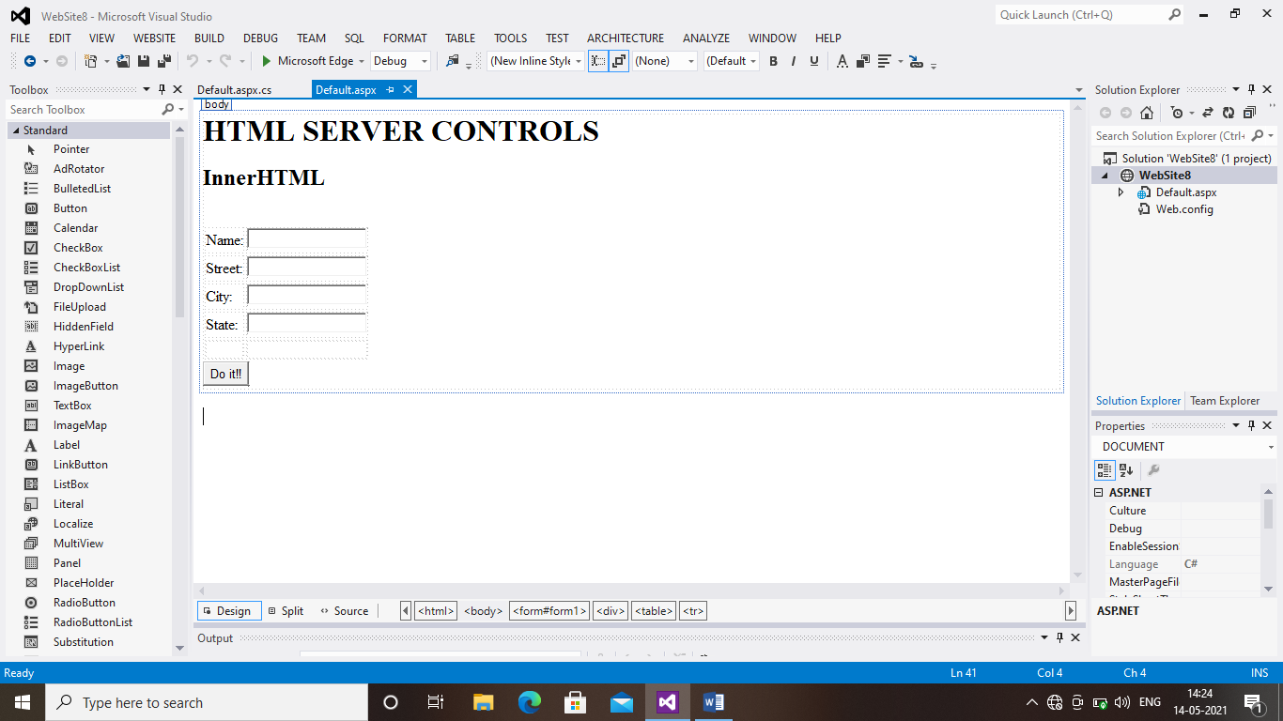

DEFAULT AXPX.CS

using System.Web;

using System.Web.UI;

using System.Web.UI.WebControls;

public partial class _Default : System.Web.UI.Page

{

protected void Page_Load(object sender, EventArgs e)

{

string strHtml = "";

strHtml += txtName.Value + "<br/>";

strHtml += txtStreet.Value + "<br/>";

strHtml += txtCity.Value + "<br/>";

strHtml += txtState.Value + "<br/>";

tdInnerHtml.InnerHtml = strHtml;

}

}

OUTPUT:

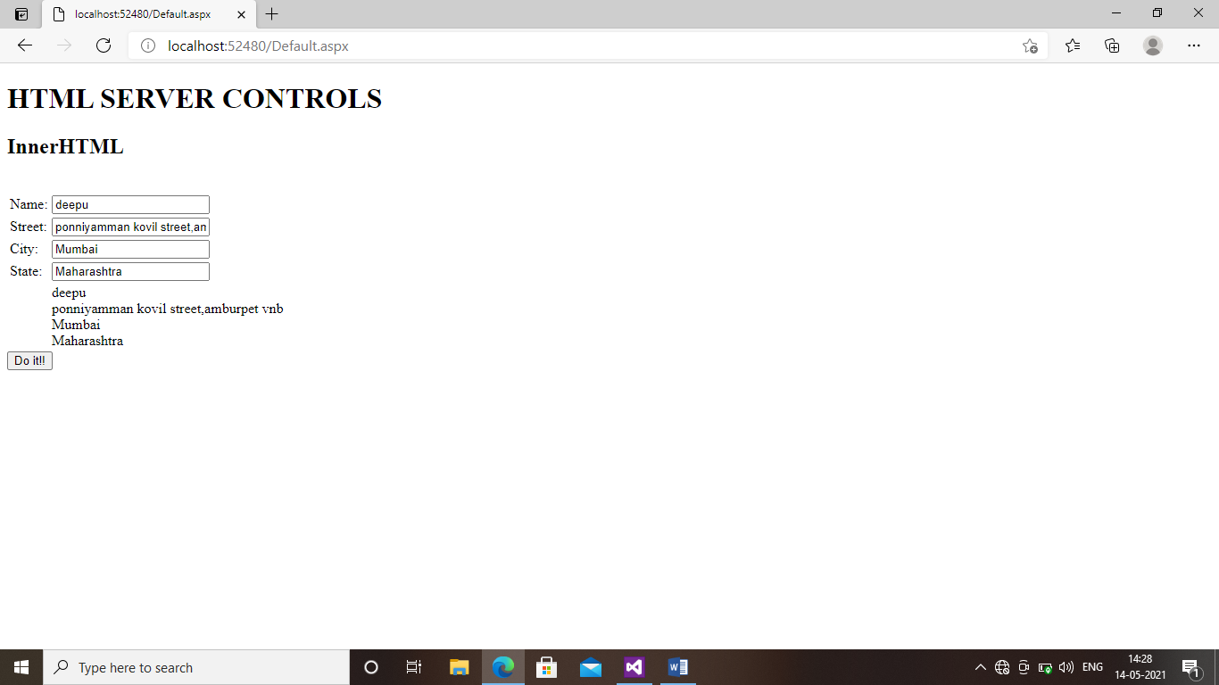

PROGRAM6:Rich Controls[Ad Rotator,Calender Control]

XmlFile.File

<?xml version="1.0" encoding="utf-8" ?>

<Advertisements>

<Ad>

<ImageUrl>~/image/cal new.jpg</ImageUrl>

<NavigateUrl>~/Default.aspx</NavigateUrl>

<AlternateText>open calender</AlternateText>

<Impressions>20</Impressions>

<keyword>calender</keyword>

</Ad>

</Advertisements>

Design page:

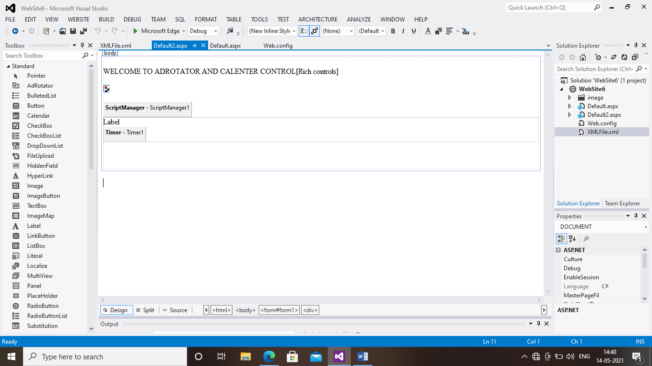

Coding:

using System;

using System.Collections.Generic;

using System.Linq;

using System.Web;

using System.Web.UI;

using System.Web.UI.WebControls;

public partial class _Default : System.Web.UI.Page

{

protected void Page_Load(object sender, EventArgs e)

{

if (!IsPostBack)

{

Calendar1.Visible = false;

}

}

protected void ImageButton1_Click(object sender, ImageClickEventArgs e)

{

Calendar1.Visible = true;

}

protected void Calendar1_SelectionChanged(object sender, EventArgs e)

{

TextBox1.Text = Calendar1.SelectedDate.ToString("d");

Calendar1.Visible = false;

}

}

DEFAULT ASPX-1 SOURCE CODE

<%@ Page Language="C#" AutoEventWireup="true" CodeFile="Default2.aspx.cs" Inherits="Default2" %>

<!DOCTYPE html>

<html xmlns="http://www.w3.org/1999/xhtml">

<head runat="server">

<title></title>

</head>

<body>

<form id="form1" runat="server">

<div>

&nbsp;

<br />

WELCOME TO ADROTATOR AND CALENTER CONTROL[Rich controls]<br />

<br />

<asp:AdRotator ID="AdRotator1" runat="server" AdvertisementFile="~/XMLFile.xml" />

<br />

<br />

<asp:ScriptManager ID="ScriptManager1" runat="server">

</asp:ScriptManager>

<asp:UpdatePanel ID="UpdatePanel1" runat="server">

<ContentTemplate>

<asp:Label ID="Label1" runat="server" Text="Label"></asp:Label>

<asp:Timer ID="Timer1" runat="server" Interval="1000" OnTick="Timer1_Tick">

</asp:Timer>

</ContentTemplate>

<Triggers>

<asp:AsyncPostBackTrigger ControlID="Timer1" EventName="Tick" />

</Triggers>

</asp:UpdatePanel>

<br />

<br />

<br />

</div>

</form>

</body>

</html>

DESIGN PAGE-2

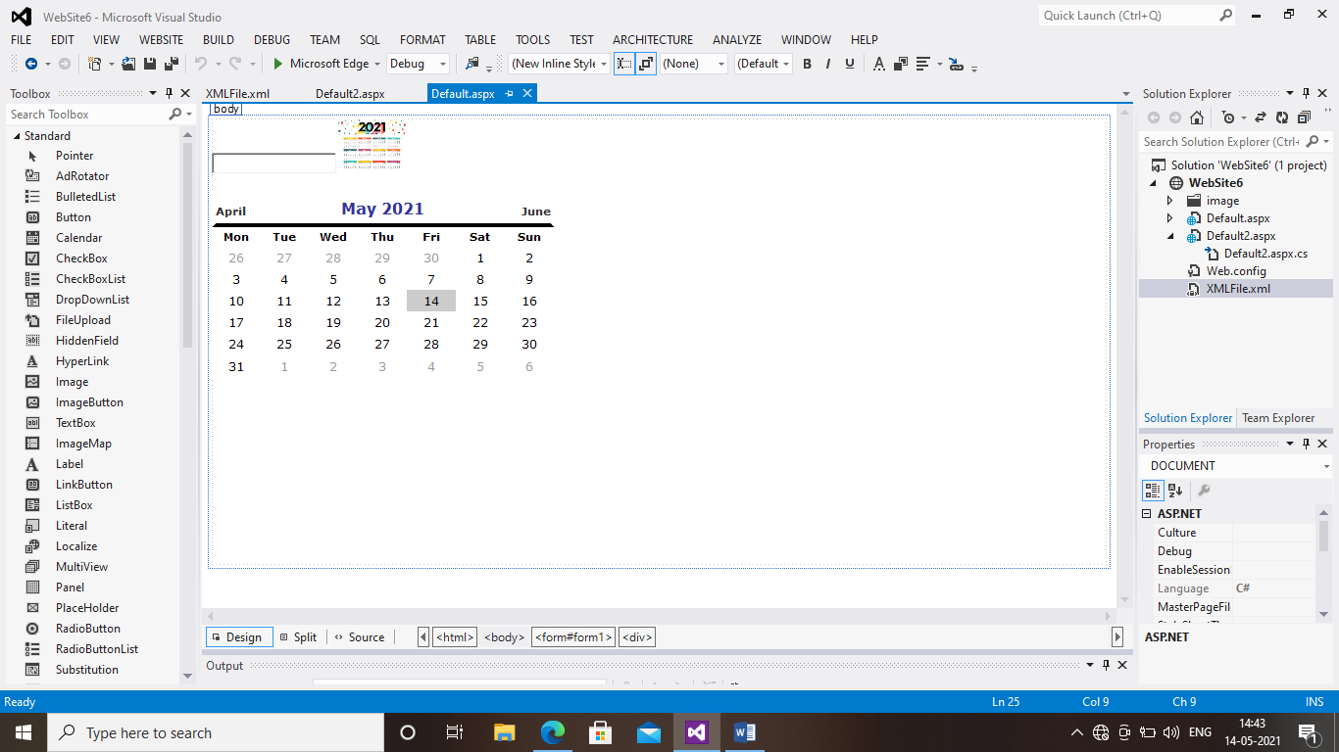

DEFAULT ASPX-2 SOURCE CODE

<%@ Page Language="C#" AutoEventWireup="true" CodeFile="Default.aspx.cs" Inherits="_Default" %>

<!DOCTYPE html>

<html xmlns="http://www.w3.org/1999/xhtml">

<head runat="server">

<title></title>

</head>

<body>

<form id="form1" runat="server">

<div>

<asp:TextBox ID="TextBox1" runat="server"></asp:TextBox>

<asp:ImageButton ID="ImageButton1" runat="server" Height="57px" ImageUrl="~/image/calender.jpg" OnClick="ImageButton1_Click" />

<br />

<br />

<asp:Calendar ID="Calendar1" runat="server" BackColor="White" BorderColor="White" BorderWidth="1px" Font-Names="Verdana" Font-Size="9pt" ForeColor="Black" Height="190px" NextPrevFormat="FullMonth" OnSelectionChanged="Calendar1_SelectionChanged" Width="350px">

<DayHeaderStyle Font-Bold="True" Font-Size="8pt" />

<NextPrevStyle Font-Bold="True" Font-Size="8pt" ForeColor="#333333" VerticalAlign="Bottom" />

<OtherMonthDayStyle ForeColor="#999999" />

<SelectedDayStyle BackColor="#333399" ForeColor="White" />

<TitleStyle BackColor="White" BorderColor="Black" BorderWidth="4px" Font-Bold="True" Font-Size="12pt" ForeColor="#333399" />

<TodayDayStyle BackColor="#CCCCCC" />

</asp:Calendar>

<br />

<br />

<br />

<br />

<br />

<br />

<br />

<br />

<br />

<br />

</div>

</form>

</body>

</html>

CODING:

using System;

using System.Collections.Generic;

using System.Linq;

using System.Web;

using System.Web.UI;

using System.Web.UI.WebControls;

public partial class _Default : System.Web.UI.Page

{

protected void Page_Load(object sender, EventArgs e)

{

}

protected void Timer1_Tick(object sender, EventArgs e)

{

Label1.Text = DateTime.Now.ToString();

}

}

OUTPUT-1

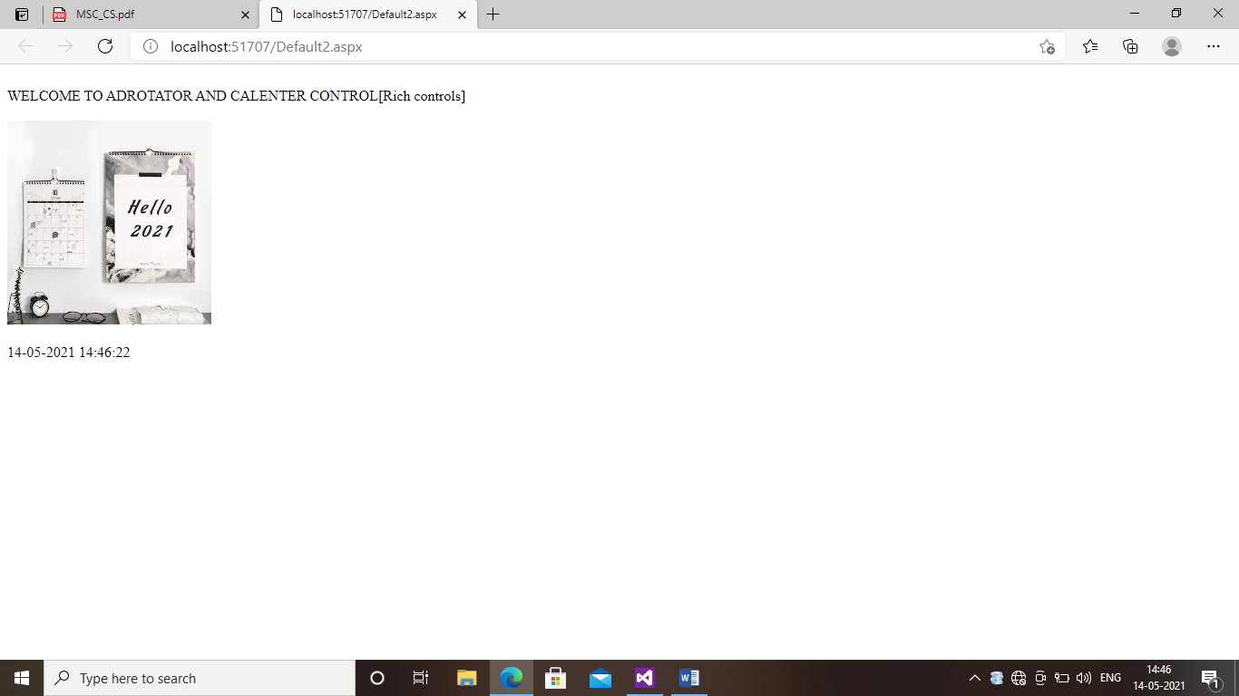

OUTPUT-2

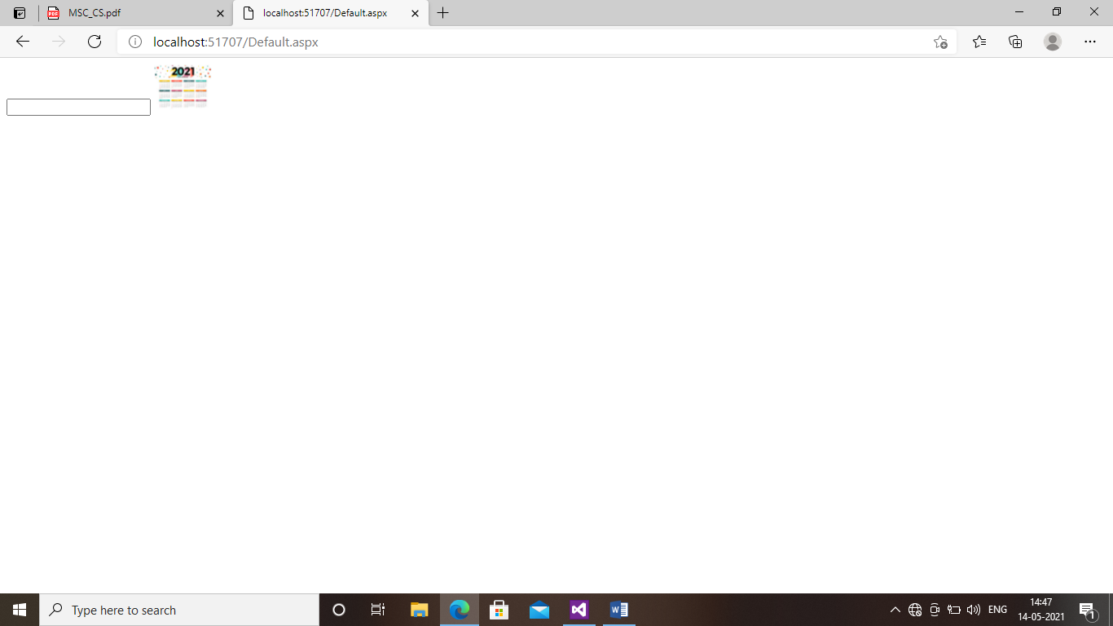

OUTPUT-3

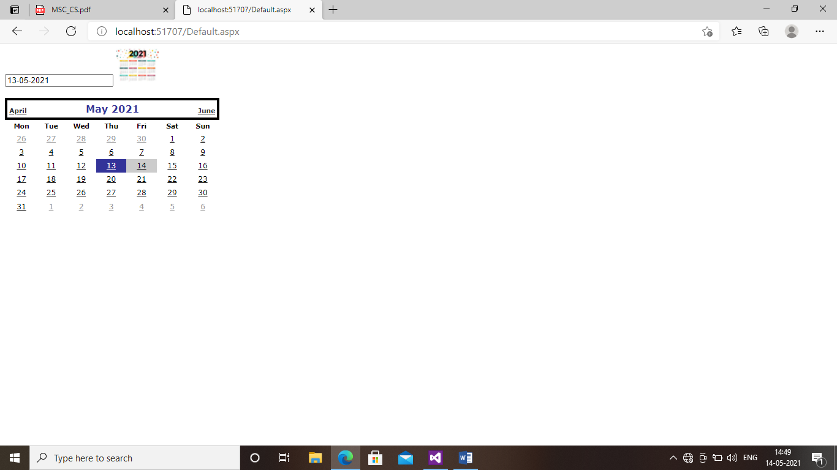

PROGRAM2:VIEW STATE

DEFAULT ASPX :SOURCE CODE

<%@ Page Language="C#" AutoEventWireup="true" CodeFile="Default.aspx.cs" Inherits="_Default" %>

<!DOCTYPE html>

<html xmlns="http://www.w3.org/1999/xhtml">

<head runat="server">

<title></title>

</head>

<body>

<form id="form1" runat="server">

<div>

User Name:-<asp:textbox id="TextBox1" runat="server"></asp:textbox>

<br />

Password :-<asp:textbox id="TextBox2" runat="server"></asp:textbox>

<br />

<asp:button id="Button1" runat="server" onclick="Button1_Click" text="Submit" />

<asp:button id="Button3" runat="server" onclick="Button3_Click" text="Restore" />

</div>

</form>

</body>

</html>

DESIGN PAGE:

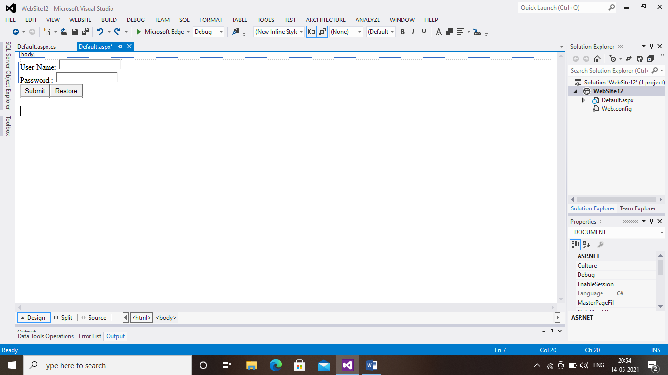

CODING:

using System;

using System.Collections.Generic;

using System.Linq;

using System.Web;

using System.Web.UI;

using System.Web.UI.WebControls;

public partial class _Default : System.Web.UI.Page

{

public string a, b;

protected void Button1_Click(object sender, EventArgs e)

{

ViewState["name"] = TextBox1.Text;

ViewState["password"] = TextBox2.Text;

//after clicking on Button TextBox value Will be Cleared

TextBox1.Text = TextBox2.Text = string.Empty;

}

protected void Button3_Click(object sender, EventArgs e)

{

if (ViewState["name"] != null)

{

TextBox1.Text = ViewState["name"].ToString();

}

if (ViewState["password"] != null)

{

TextBox2.Text = ViewState["password"].ToString();

}

}

}

OUTPUT:

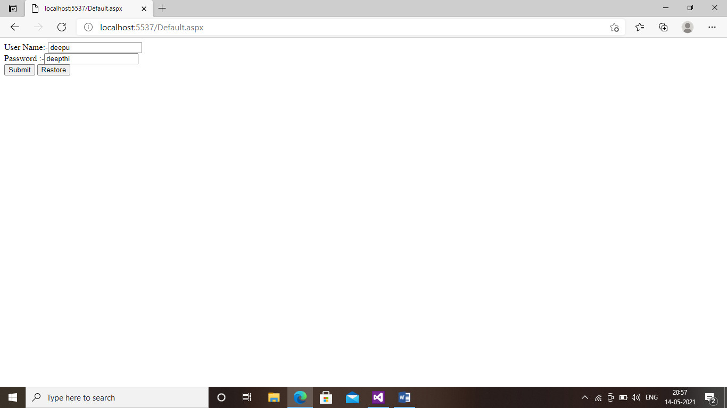

PROGRAM5:VALIDATION CONTROL

SOURCE CODE:

<%@ Page Language="C#" AutoEventWireup="true" CodeBehind="WebForm1.aspx.cs" Inherits="validation_control.WebForm1" %>

<!DOCTYPE html>

<html xmlns="http://www.w3.org/1999/xhtml">

<head runat="server">

<title></title>

</head>

<body>

<form id="form1" runat="server">

<div>

<asp:Label ID="Label1" runat="server" Text="ReauiredField Validator Control Example"

Font-Bold="true" Font-size="Medium" Font-Underline="true"></asp:Label> <br /> <br />

<asp:Label ID="Label2" runat="server" Font-Bold="true" Font-size="Small" Text="User Name:"> </asp:Label>

&nbsp;&nbsp;

<asp:TextBox ID="TextBox1" runat="server" Height="22px" Width="152px"></asp:TextBox>

<asp:RequiredFieldValidator ID="Requiredfieldvalidator1" runat="server" ControlToValidate="TextBox1"

ErrorMessage="User name can not be empty"></asp:RequiredFieldValidator>

<br />

<br />

<asp:Label ID="Label3" runat="server" Font-Bold="true" Font-Size="Small" Text="Password:"></asp:Label>

<asp:TextBox ID="TextBox2" runat="server" Height="22px" TextMode="Password" Width="175px"></asp:TextBox>

<asp:RequiredFieldValidator ID="RequiredValidator2" runat="server" ControlToValidate="TextBox2"

ErrorMessage="Password can not be empty "></asp:RequiredFieldValidator>

<br />

<br />

&nbsp;&nbsp;&nbsp;&nbsp;&nbsp;&nbsp;&nbsp;&nbsp;&nbsp;&nbsp;&nbsp;&nbsp;&nbsp;&nbsp;&nbsp;&nbsp;&nbsp;&nbsp;&nbsp;&nbsp;&nbsp;&nbsp;&nbsp;&nbsp;&nbsp;&nbsp;&nbsp;&nbsp;&nbsp;&nbsp;&nbsp;&nbsp;&nbsp;&nbsp;&nbsp;&nbsp;&nbsp;&nbsp;&nbsp;&nbsp;&nbsp;&nbsp;&nbsp;&nbsp;&nbsp;&nbsp;&nbsp;&nbsp;&nbsp;&nbsp;

<asp:Button ID="Button1" runat="server" BackColor="Black" Font-Bold="true" Font-Size="Medium" ForeColor="White" Text="Submit" OnClick="Button1_Click" /></p>

</div>

</form>

</body>

</html>

DESIGN PAGE:

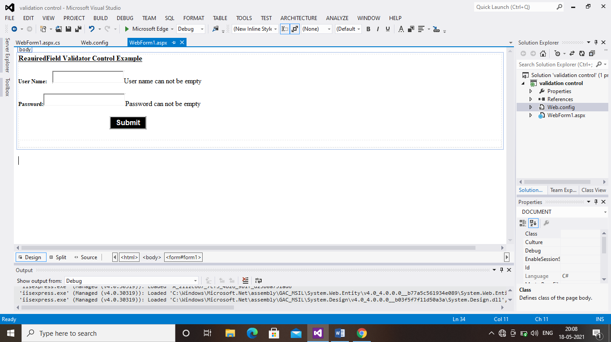

CODING:

using System;

using System.Collections.Generic;

using System.Linq;

using System.Web;

using System.Web.UI;

using System.Web.UI.WebControls;

namespace validation_control

{

public partial class WebForm1 : System.Web.UI.Page

{

protected void Page_Load(object sender, EventArgs e)

{

}

protected void Button1_Click(object sender, EventArgs e)

{

Response.Write("Your Registration is successfull");

}

}

}

OUTPUT-1:

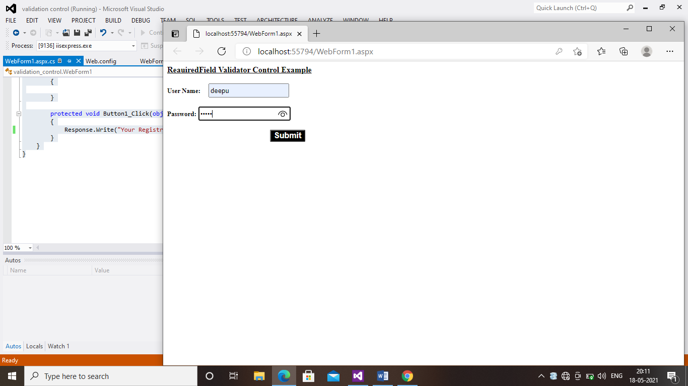

OUTPUT-2:

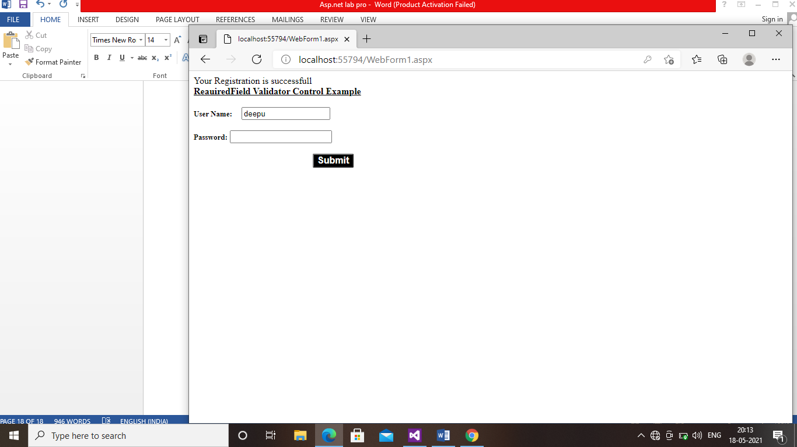

PROGRAM 10:USER CONTROL

Source code:

<%@ Page Title="Home Page" Language="C#" MasterPageFile="~/Site.Master" AutoEventWireup="true" CodeBehind="Default.aspx.cs" Inherits="WebApplication8._Default" %>

<%@ Register TagPrefix="UC" TagName="UCLOGIN" Src="~/WebUserControl1.ascx" %>

<asp:Content runat="server" ID="FeaturedContent" ContentPlaceHolderID="FeaturedContent">

<section class="featured">

<div class="content-wrapper">

<hgroup class="title">

<h1><%: Title %>.</h1>

<h2>Modify this template to jump-start your ASP.NET application.</h2>

</hgroup>

<p>

To learn more about ASP.NET, visit <a href="http://asp.net" title="ASP.NET Website">http://asp.net</a>.

The page features <mark>videos, tutorials, and samples</mark> to help you get the most from ASP.NET.

If you have any questions about ASP.NET visit

<a href="http://forums.asp.net/18.aspx" title="ASP.NET Forum">our forums</a>.

</p>

</div>

</section>

</asp:Content>

<asp:Content runat="server" ID="BodyContent" ContentPlaceHolderID="MainContent">

<h3>We suggest the following:</h3>

<ol class="round">

<li class="one">

<h5>Getting Started</h5>

ASP.NET Web Forms lets you build dynamic websites using a familiar drag-and-drop, event-driven model.

A design surface and hundreds of controls and components let you rapidly build sophisticated, powerful UI-driven sites with data access.

<a href="http://go.microsoft.com/fwlink/?LinkId=245146">Learn more…</a>

</li>

<li class="two">

<h5>Add NuGet packages and jump-start your coding</h5>

NuGet makes it easy to install and update free libraries and tools.

<a href="http://go.microsoft.com/fwlink/?LinkId=245147">Learn more…</a>

</li>

<li class="three">

<h5>Find Web Hosting</h5>

You can easily find a web hosting company that offers the right mix of features and price for your applications.

<a href="http://go.microsoft.com/fwlink/?LinkId=245143">Learn more…</a>

</li>

</ol>

<div>

<uc:UCLOGIN id="idlogin" runat="server" />

</div>

</asp:Content>

Design page:

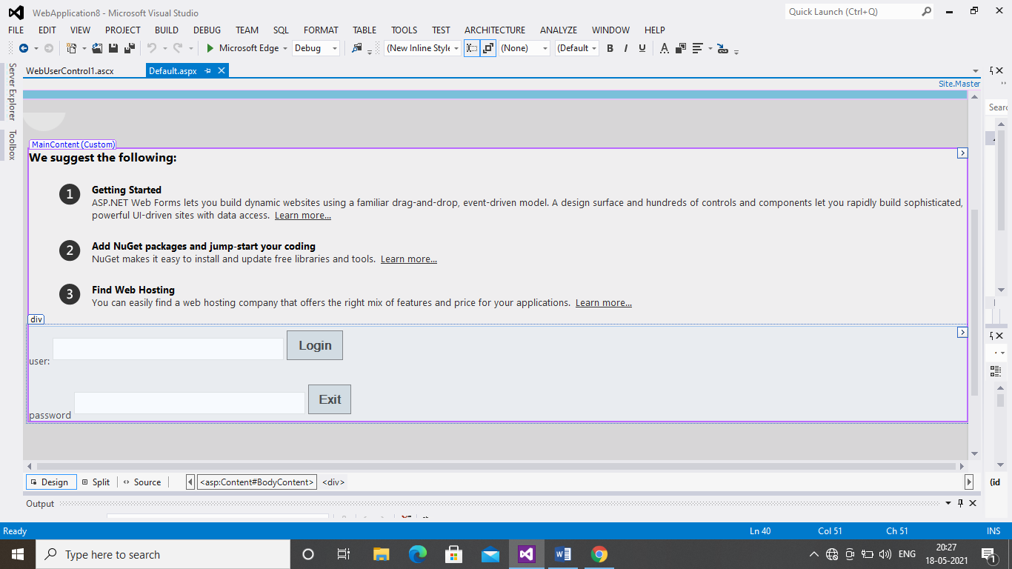

CODING (Web user control):

<%@ Control Language="C#" AutoEventWireup="true" CodeBehind="WebUserControl1.ascx.cs" Inherits="WebApplication8.WebUserControl1" %>

<asp:Label ID="Label1" runat="server" Text="user:"></asp:Label>

<asp:TextBox ID="TextBox1" runat="server"></asp:TextBox>

<asp:Button ID="Button1" runat="server" Text="Login" />

<p>

<asp:Label ID="Label2" runat="server" Text="password"></asp:Label>

<asp:TextBox ID="TextBox2" runat="server"></asp:TextBox>

<asp:Button ID="Button2" runat="server" Text="Exit" />

</p>

OUTPUT-1:

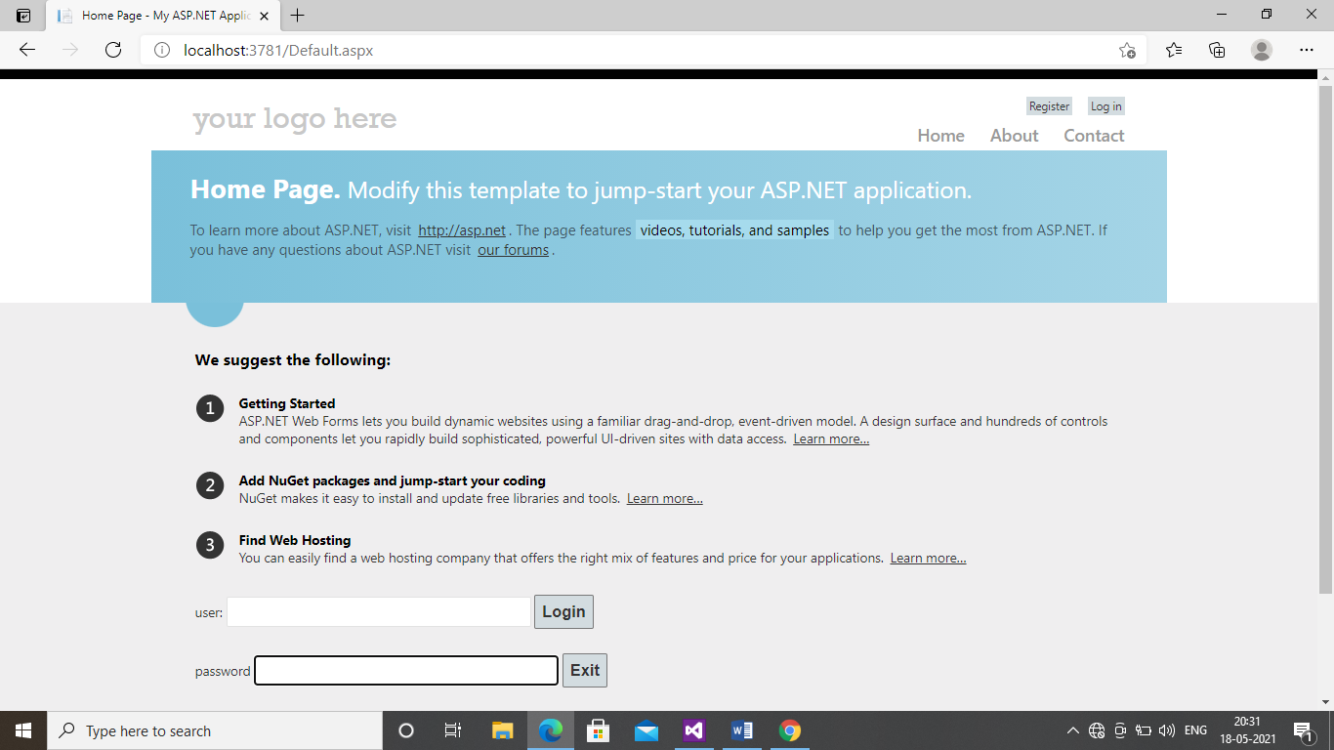

OUTPUT 2:

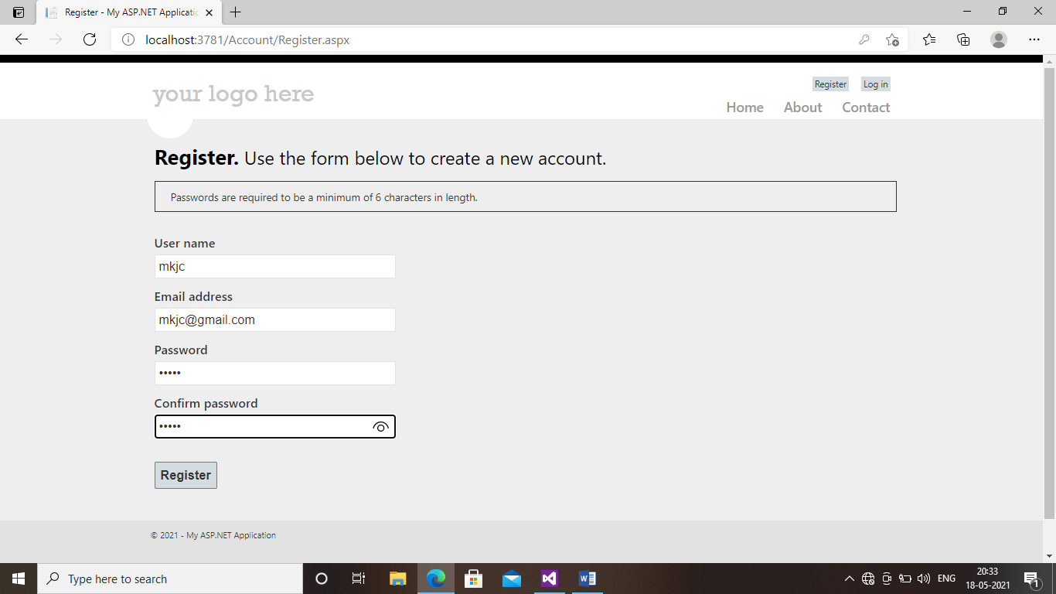

OUTPUT-3:

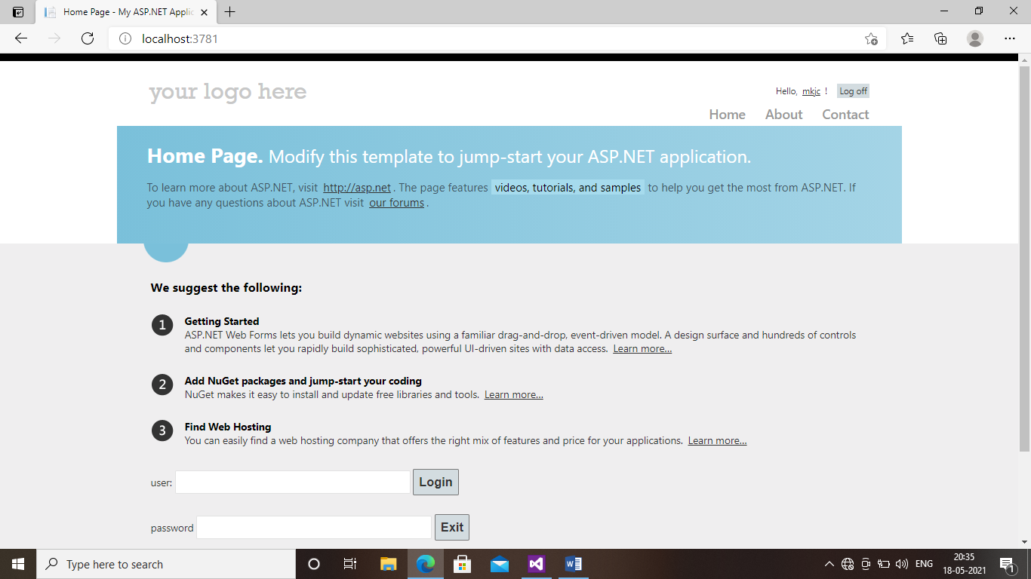

PROGRAM1:CUSTOM CONTROL

Source code:

<%@ Page Language="C#" AutoEventWireup="true" CodeFile="MyCustomControl.aspx.cs" Inherits="MyCustomControl" %>

<%@ Register Assembly="CustomControl" Namespace="CustomControl" TagPrefix="cc1" %>

<!DOCTYPE html>

<html xmlns="http://www.w3.org/1999/xhtml">

<head runat="server">

<title></title>

<style type="text/css">

.auto-style1 {

width: 136%;

height: 450px;

}

.auto-style2 {}

.auto-style3 {

}

.auto-style5 {

width: 302px;

}

.auto-style6 {

font-size: x-large;

}

.auto-style7 {

font-size: larger;

}

.auto-style8 {

font-size: x-large;

width: 14px;

}

.auto-style9 {

width: 14px;

}

</style>

</head>

<body>

<form id="form1" runat="server">

<div>

<cc1:ServerControl1 ID="ServerControl1" runat="server" Text="My First Custom Control " />

<table class="auto-style1">

<tr>

<td colspan="4" style="font-size: 80px; font-weight: 800; color: #800000">&nbsp;&nbsp;&nbsp;&nbsp;&nbsp;&nbsp;&nbsp;&nbsp;&nbsp;&nbsp;&nbsp;&nbsp;&nbsp;&nbsp;&nbsp;&nbsp;&nbsp;&nbsp;&nbsp;&nbsp;&nbsp;&nbsp;&nbsp;&nbsp;&nbsp;&nbsp;&nbsp;&nbsp;&nbsp;&nbsp;&nbsp;&nbsp;&nbsp;&nbsp;&nbsp;&nbsp;&nbsp;&nbsp;&nbsp;&nbsp;&nbsp;&nbsp;&nbsp;&nbsp;&nbsp;&nbsp;&nbsp;&nbsp;&nbsp;&nbsp;&nbsp;&nbsp;&nbsp;&nbsp;&nbsp;&nbsp;&nbsp;&nbsp;&nbsp;&nbsp;&nbsp;&nbsp;&nbsp;&nbsp;&nbsp;&nbsp;&nbsp;&nbsp;&nbsp;&nbsp;&nbsp;&nbsp;&nbsp;&nbsp;&nbsp;&nbsp;&nbsp;&nbsp;&nbsp;&nbsp;&nbsp;&nbsp;&nbsp;&nbsp;&nbsp;&nbsp;&nbsp;&nbsp; &nbsp;&nbsp;&nbsp;&nbsp;&nbsp;&nbsp;&nbsp;&nbsp;&nbsp;&nbsp;&nbsp;&nbsp;&nbsp;&nbsp;&nbsp;&nbsp;&nbsp;&nbsp;<span class="auto-style7">BILLING SYSTEM</span></td>

</tr>

<tr>

<td class="auto-style2">&nbsp;&nbsp;&nbsp;&nbsp;&nbsp;&nbsp;&nbsp;&nbsp;&nbsp;&nbsp;&nbsp;&nbsp;&nbsp;&nbsp;&nbsp;&nbsp;&nbsp;&nbsp;&nbsp;&nbsp;&nbsp;&nbsp;&nbsp; <strong><span class="auto-style6">&nbsp; PRODUCT</span></strong></td>

<td class="auto-style5">&nbsp;&nbsp;&nbsp;&nbsp;&nbsp;&nbsp;&nbsp;&nbsp;&nbsp;&nbsp;&nbsp;&nbsp;&nbsp;&nbsp;&nbsp;&nbsp; <strong><span class="auto-style6">&nbsp; PRICE</span></strong></td>

<td class="auto-style6"><strong>QUANTITY</strong></td>

<td class="auto-style8"><strong>AMOUNT</strong></td>

</tr>

<tr>

<td class="auto-style2">

<asp:DropDownList ID="DropDownList1" runat="server" AutoPostBack="True" OnSelectedIndexChanged="DropDownList1_SelectedIndexChanged">

<asp:ListItem>---select---</asp:ListItem>

<asp:ListItem Value="150">T-shirt</asp:ListItem>

<asp:ListItem Value="500">Shirt</asp:ListItem>

<asp:ListItem Value="800">Shoes</asp:ListItem>

<asp:ListItem Value="100">Braslate</asp:ListItem>

<asp:ListItem Value="12500">Gold rings</asp:ListItem>

<asp:ListItem Value="650">silver rings</asp:ListItem>

<asp:ListItem></asp:ListItem>

</asp:DropDownList>

</td>

<td class="auto-style5">

<asp:Label ID="Label1" runat="server"></asp:Label>

</td>

<td class="auto-style3">

<asp:DropDownList ID="DropDownList2" runat="server" AutoPostBack="True" OnSelectedIndexChanged="DropDownList2_SelectedIndexChanged">

<asp:ListItem>---select---</asp:ListItem>

<asp:ListItem>01</asp:ListItem>

<asp:ListItem>02</asp:ListItem>

<asp:ListItem>03</asp:ListItem>

<asp:ListItem>04</asp:ListItem>

<asp:ListItem>05</asp:ListItem>

<asp:ListItem>06</asp:ListItem>

<asp:ListItem>07</asp:ListItem>

<asp:ListItem>08</asp:ListItem>

<asp:ListItem>09</asp:ListItem>

<asp:ListItem>10</asp:ListItem>

</asp:DropDownList>

</td>

<td class="auto-style9">

<asp:Label ID="Label2" runat="server"></asp:Label>

</td>

</tr>

<tr>

<td class="auto-style2">&nbsp;</td>

<td class="auto-style5">&nbsp;</td>

<td class="auto-style3">&nbsp;</td>

<td class="auto-style9">&nbsp;</td>

</tr>

<tr>

<td class="auto-style2" colspan="2">&nbsp;&nbsp;&nbsp;&nbsp;&nbsp;&nbsp;&nbsp;&nbsp;&nbsp;&nbsp;&nbsp;&nbsp;&nbsp;&nbsp;&nbsp;&nbsp;&nbsp;&nbsp;&nbsp;&nbsp;&nbsp;&nbsp;&nbsp;&nbsp;&nbsp;&nbsp;&nbsp;&nbsp;&nbsp;&nbsp;&nbsp;&nbsp;&nbsp;&nbsp;&nbsp;&nbsp;&nbsp;&nbsp;&nbsp;&nbsp;&nbsp;&nbsp;&nbsp;&nbsp;&nbsp;&nbsp;&nbsp;&nbsp;&nbsp;&nbsp;&nbsp;&nbsp;&nbsp;&nbsp;&nbsp;&nbsp;&nbsp;&nbsp;&nbsp;&nbsp;&nbsp;&nbsp;&nbsp;&nbsp;&nbsp;&nbsp; <strong>PRODUCT NAME</strong></td>

<td class="auto-style3" colspan="2">

<asp:Label ID="Label3" runat="server"></asp:Label>

</td>

</tr>

<tr>

<td class="auto-style2" colspan="2">&nbsp;&nbsp;&nbsp;&nbsp;&nbsp;&nbsp;&nbsp;&nbsp;&nbsp;&nbsp;&nbsp;&nbsp;&nbsp;&nbsp;&nbsp;&nbsp;&nbsp;&nbsp;&nbsp;&nbsp;&nbsp;&nbsp;&nbsp;&nbsp;&nbsp;&nbsp;&nbsp;&nbsp;&nbsp;&nbsp;&nbsp;&nbsp;&nbsp;&nbsp;&nbsp;&nbsp;&nbsp;&nbsp;&nbsp;&nbsp;&nbsp;&nbsp;&nbsp;&nbsp;&nbsp;&nbsp;&nbsp;&nbsp;&nbsp;&nbsp;&nbsp;&nbsp;&nbsp;&nbsp;&nbsp;&nbsp;&nbsp;&nbsp;&nbsp;&nbsp;&nbsp;&nbsp;&nbsp;&nbsp;&nbsp;&nbsp; <strong>TOTAL AMOUNT</strong></td>

<td class="auto-style3" colspan="2">

<asp:Label ID="Label4" runat="server"></asp:Label>

</td>

</tr>

<tr>

<td class="auto-style2" colspan="2">&nbsp;&nbsp;&nbsp;&nbsp;&nbsp;&nbsp;&nbsp;&nbsp;&nbsp;&nbsp;&nbsp;&nbsp;&nbsp;&nbsp;&nbsp;&nbsp;&nbsp;&nbsp;&nbsp;&nbsp;&nbsp;&nbsp;&nbsp;&nbsp;&nbsp;&nbsp;&nbsp;&nbsp;&nbsp;&nbsp;&nbsp;&nbsp;&nbsp;&nbsp;&nbsp;&nbsp;&nbsp;&nbsp;&nbsp;&nbsp;&nbsp;&nbsp;&nbsp;&nbsp;&nbsp;&nbsp;&nbsp;&nbsp;&nbsp;&nbsp;&nbsp;&nbsp;&nbsp;&nbsp;&nbsp;&nbsp;&nbsp;&nbsp;&nbsp;&nbsp;&nbsp;&nbsp;&nbsp;&nbsp;&nbsp;&nbsp; <strong>DISCOUNT</strong></td>

<td class="auto-style3" colspan="2">

<asp:DropDownList ID="DropDownList3" runat="server" AutoPostBack="True" OnSelectedIndexChanged="DropDownList3_SelectedIndexChanged">

<asp:ListItem>---select---</asp:ListItem>

<asp:ListItem>05</asp:ListItem>

<asp:ListItem>10</asp:ListItem>

<asp:ListItem>15</asp:ListItem>

<asp:ListItem>20</asp:ListItem>

</asp:DropDownList>

</td>

</tr>

<tr>

<td class="auto-style2" colspan="2">&nbsp;&nbsp;&nbsp;&nbsp;&nbsp;&nbsp;&nbsp;&nbsp;&nbsp;&nbsp;&nbsp;&nbsp;&nbsp;&nbsp;&nbsp;&nbsp;&nbsp;&nbsp;&nbsp;&nbsp;&nbsp;&nbsp;&nbsp;&nbsp;&nbsp;&nbsp;&nbsp;&nbsp;&nbsp;&nbsp;&nbsp;&nbsp;&nbsp;&nbsp;&nbsp;&nbsp;&nbsp;&nbsp;&nbsp;&nbsp;&nbsp;&nbsp;&nbsp;&nbsp;&nbsp;&nbsp;&nbsp;&nbsp;&nbsp;&nbsp;&nbsp;&nbsp;&nbsp;&nbsp;&nbsp;&nbsp;&nbsp;&nbsp;&nbsp;&nbsp;&nbsp;&nbsp;&nbsp;&nbsp;&nbsp; <strong>&nbsp;PAY AMOUNT</strong></td>

<td class="auto-style3" colspan="2">

<asp:Label ID="Label5" runat="server"></asp:Label>

</td>

</tr>

</table>

</div>

</form>

</body>

</html>

Design page:

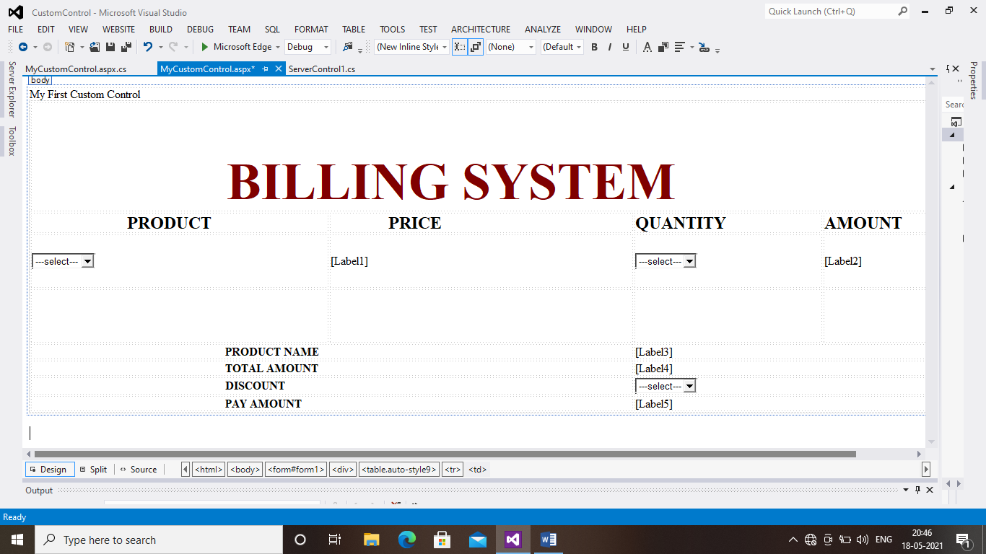

Coding:

using System;

using System.Collections.Generic;

using System.Linq;

using System.Web;

using System.Web.UI;

using System.Web.UI.WebControls;

public partial class MyCustomControl : System.Web.UI.Page

{

protected void Page_Load(object sender, EventArgs e)

{

}

protected void DropDownList1_SelectedIndexChanged(object sender, EventArgs e)

{

Label1.Text = DropDownList1.SelectedValue;

Label3.Text = DropDownList1.SelectedItem.Text;

}

protected void DropDownList2_SelectedIndexChanged(object sender, EventArgs e)

{

int a = Convert.ToInt32(DropDownList2.SelectedItem.Text);

int b = Convert.ToInt32(Label1.Text);

int c = a * b;

Label2.Text = c.ToString();

Label4.Text = Label2.Text;

}

protected void DropDownList3_SelectedIndexChanged(object sender, EventArgs e)

{

int f = Convert.ToInt32(DropDownList3.SelectedItem.Text);

int d = Convert.ToInt32(Label4.Text);

int g = d * f * 1 / 100;

int h = d - g;

Label5.Text = h.ToString();

}

}

OUTPUT:

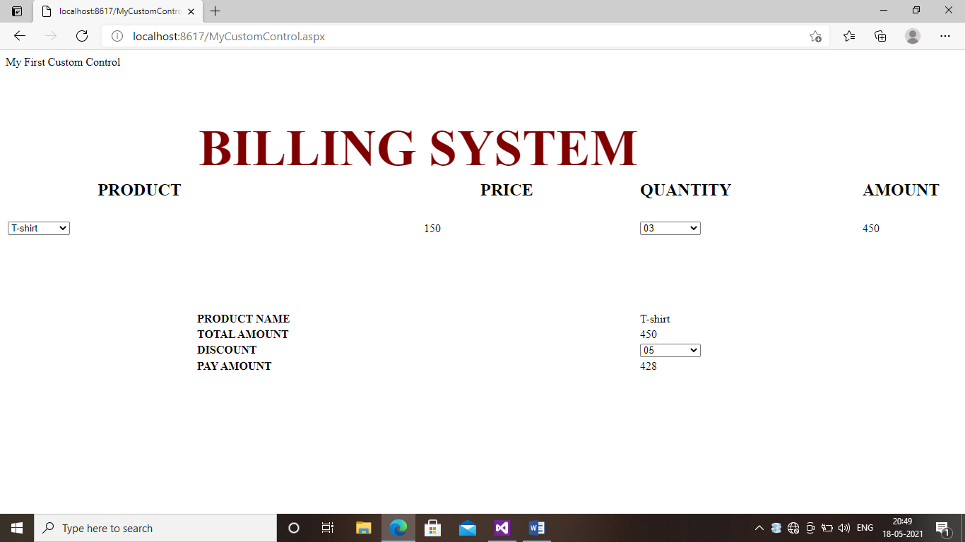

PROGRAM 08:DATA ACCESS

**PROGRAM:**

using System;

using System.Collections.Generic;

using System.ComponentModel;

using System.Data;

using System.Drawing;

using System.Linq;

using System.Text;

using System.Windows.Forms;

using System.Data.OleDb;

namespace WindowsFormsApplication14

{

public partial class Form1 : Form

{

OleDbConnection con = new OleDbConnection();

OleDbCommand cmd = new OleDbCommand();

OleDbDataReader dr;

public Form1()

{

InitializeComponent();

}

private void Form1_Load(object sender, EventArgs e){

this.employeeTableAdapter.Fill(this.employeeDataSet1.employee);

this.empTableAdapter.Fill(this.employeeDataSet.emp);

}

private void button1_Click(object sender, EventArgs e)

{

try

{

con.ConnectionString = @"Provider=Microsoft.Jet.OLEDB.4.0;Data Source=C:\Users\Lab.Lab-PC\Documents\employee.mdb;Persist Security Info=True";

con.Open();

int aa = Convert.ToInt32(textBox1.Text);

string bb = textBox2.Text;

int cc = Convert.ToInt32(textBox3.Text);

cmd = new OleDbCommand("insert into employee values ('" + aa + "','" + bb + "','" + cc + "')",con);

cmd.ExecuteNonQuery();

MessageBox.Show("One record inserted");

con.Close();

}

catch (ConstraintException ex){

MessageBox.Show(ex.Message);

}}

private void button2_Click(object sender, EventArgs e){

con.ConnectionString = @"Provider=Microsoft.Jet.OLEDB.4.0;Data Source=C:\Users\Lab.Lab-PC\Documents\employee.mdb;Persist Security Info=False";

con.Open();

int aa = Convert.ToInt32(textBox1.Text);

string bb = textBox2.Text;

int cc = Convert.ToInt32(textBox3.Text);

string abc = "update employee set Emp_ID='" + aa + "',Emp_Name='" + bb + "',Salary='" + cc + "'";

cmd = new OleDbCommand(abc, con);

cmd.ExecuteNonQuery();

MessageBox.Show("one record updated");

con.Close();

}

private void button3_Click(object sender, EventArgs e){

con.ConnectionString = @"Provider=Microsoft.Jet.OLEDB.4.0;Data Source=C:\Users\Lab.Lab-PC\Documents\employee.mdb;Persist Security Info=False";

con.Open();

int aa = Convert.ToInt32(textBox1.Text);

cmd = new OleDbCommand("delete from employee where Emp_ID='" + aa + "'", con);

cmd.ExecuteNonQuery();

MessageBox.Show("One record deleted");

con.Close();

}

private void button4_Click(object sender, EventArgs e){

con.ConnectionString = @"Provider=Microsoft.Jet.OLEDB.4.0;Data Source=C:\Users\Lab.Lab-PC\Documents\employee.mdb;Persist Security Info=False";

con.Open();

int aa = Convert.ToInt32(textBox1.Text);

string abc = "select * from employee where Emp_ID ='" + aa + "'";

cmd = new OleDbCommand(abc, con);

MessageBox.Show("one record searched");

dr = cmd.ExecuteReader();

DataTable dt = new DataTable();

dt.Load(dr);

dataGridView1.DataSource = dt;

con.Close();

}

private void button5_Click(object sender, EventArgs e){

textBox1.Text = "";

textBox2.Text = "";

textBox3.Text = "";

}

private void button6_Click(object sender, EventArgs e){

this.Close();

}

}

}

Design page:

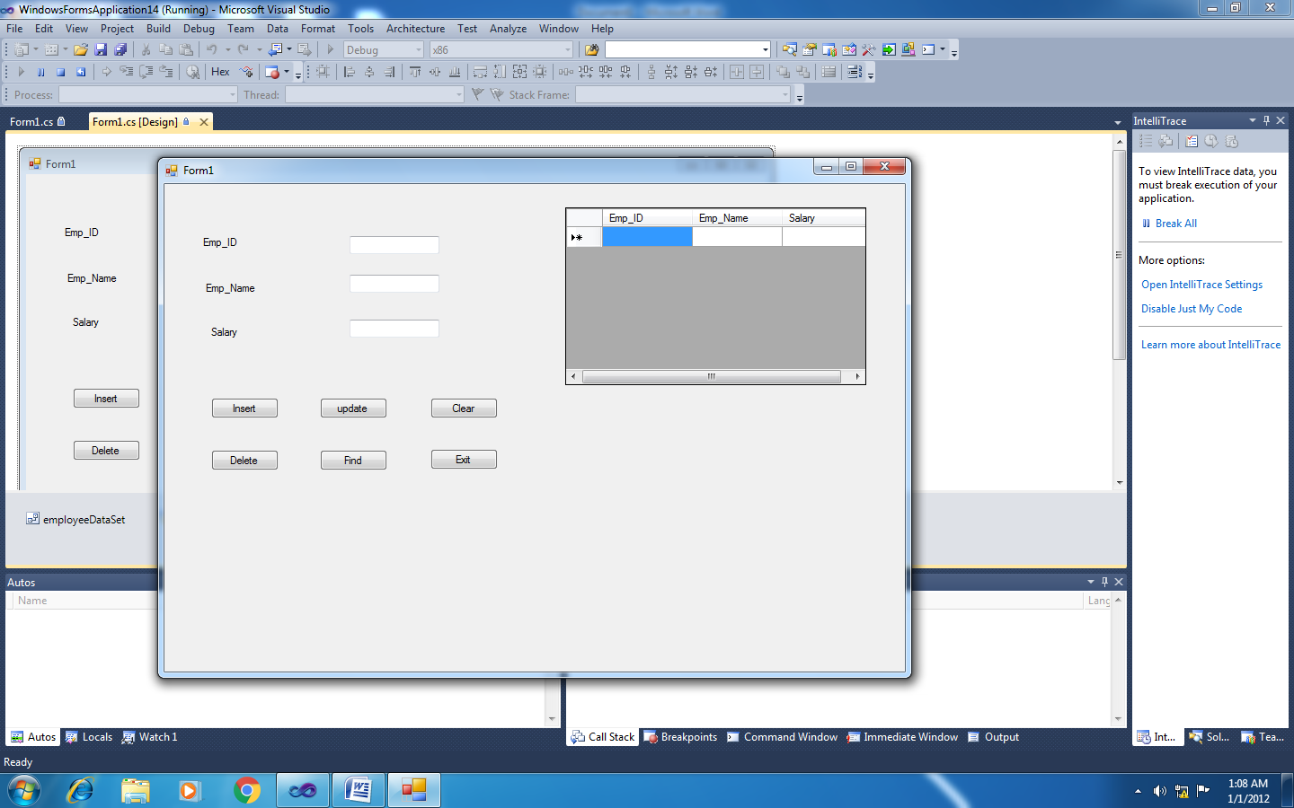

OUTPUT:

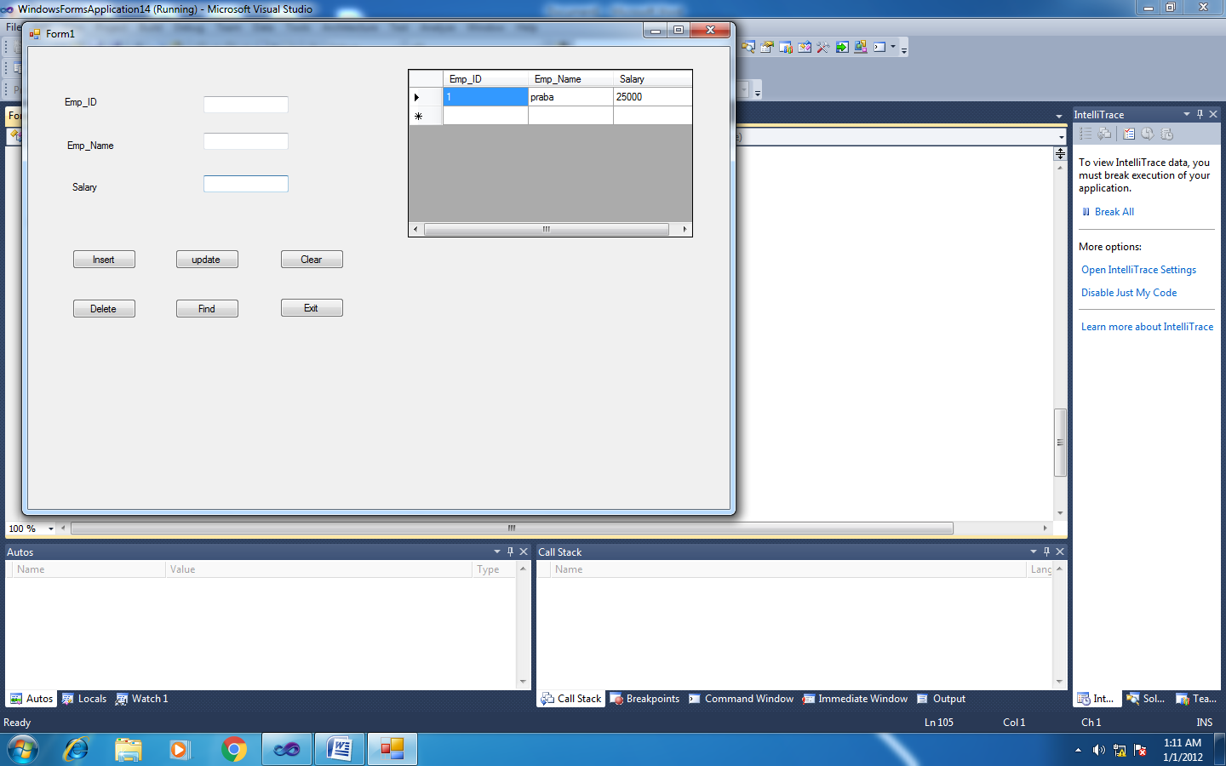

PROGRAM 08:COMPONENTS

**Coding:**

**Default.aspx:**

<%@ Page Language="C#" AutoEventWireup="true" CodeBehind="WebForm1.aspx.cs" Inherits="WebApplication5.WebForm1" %>

<!DOCTYPE html PUBLIC "-//W3C//DTD XHTML 1.0 Transitional//EN" "http://www.w3.org/TR/xhtml1/DTD/xhtml1-transitional.dtd">

<html xmlns="http://www.w3.org/1999/xhtml">

<head runat="server">

<title>Grid view</title>

</head>

<body>

<form id="form1" runat="server">&nbsp;<div>

</div>

<asp:GridView ID="Gridview1" runat="server" AutoGenerateColumns="false"

DatakeyNames="pid" DataSourceID="sqlDataSource1">

<Columns>

<asp:BoundField DataField="pid" HeaderText="pid" SortExpression="pid" />

<asp:BoundField DataField="pname" HeaderText="pname" SortExpression="pname" />

<asp:BoundField DataField="punit" HeaderText="punit" SortExpression="punit" />

<asp:BoundField DataField="price" HeaderText="price" SortExpression="price" />

<asp:BoundField DataField="stock" HeaderText="stock" SortExpression="stock" />

</Columns>

</asp:GridView>

<asp:SqlDataSource ID="SqlDataSource1" runat="server"

ConnectionString="<%$ ConnectionStrings:GriddbConnectionString %>"

SelectCommand="SELECT * FROM [Gridtable]"></asp:SqlDataSource>

</form>

</body>

</html>

**Design Page:**

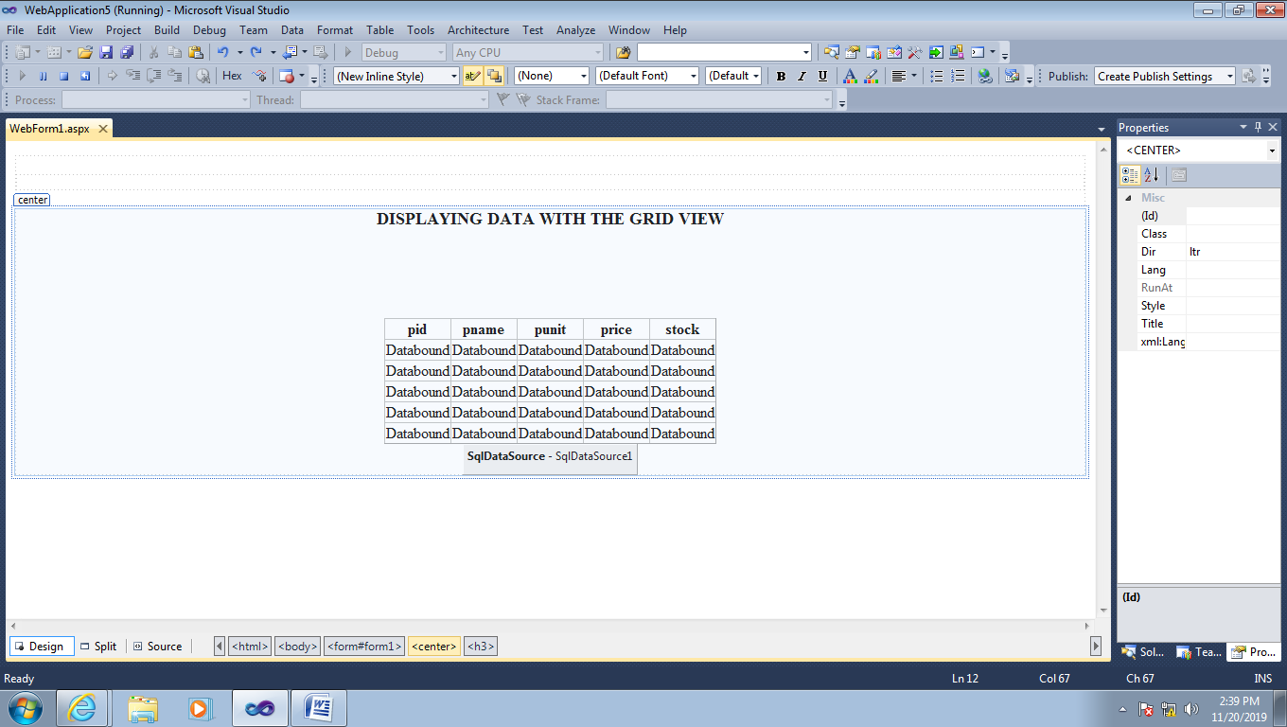

**Output:**

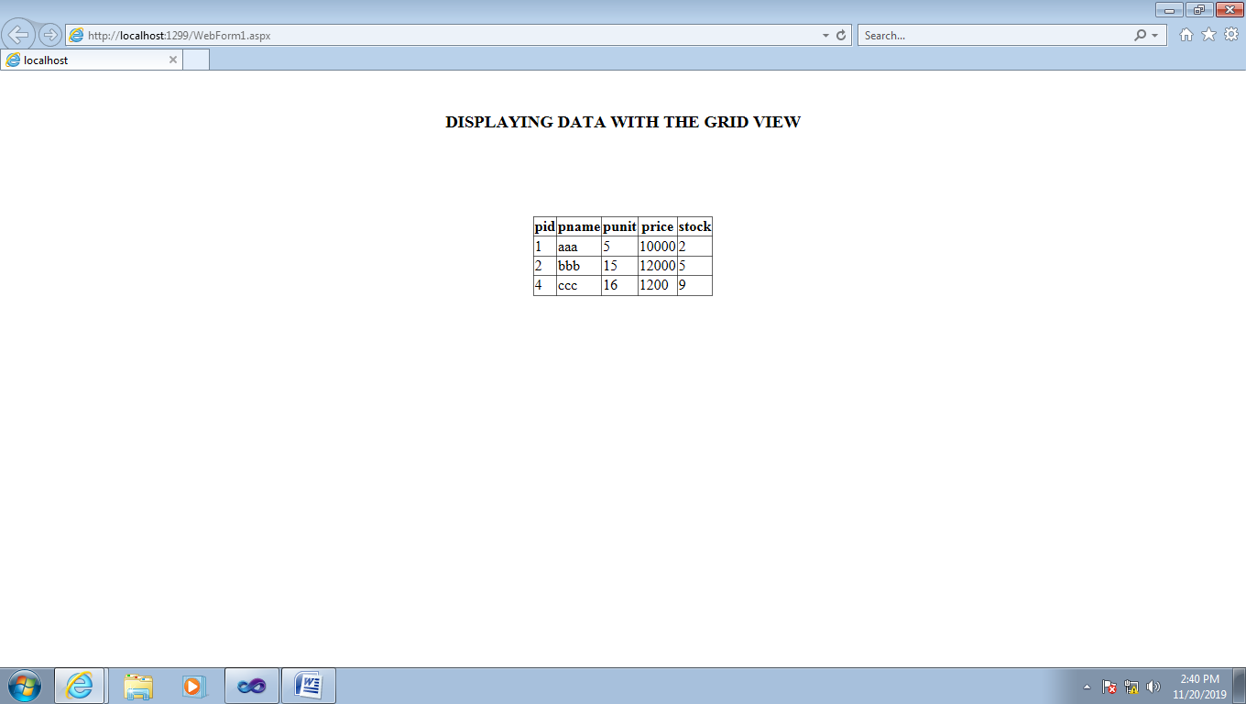

PROGRAM 4: Web Control Classes & Control Tags

Web Form1.aspx (SOURCE CODE)

<%@ Page Language="C#" AutoEventWireup="true" CodeBehind="WebForm1.aspx.cs" Inherits="WebApplication11.WebForm1" %>

<!DOCTYPE html>

<html xmlns="http://www.w3.org/1999/xhtml">

<head runat="server">

<title></title>

</head>

<body>

<form id="form1" runat="server">

<div style="background-image: url('img/h2.jpg'); height: 740px; width: 1099px;">

<br />

<br />

<br />

<br />

<br />

<br />

<br />

<br />

<br />

<br />

<br />

<br />

<br />

<br />

<br />

<br />

<br />

<br />

&nbsp;&nbsp;&nbsp;&nbsp;&nbsp;&nbsp;&nbsp;&nbsp;&nbsp;&nbsp;&nbsp;&nbsp;&nbsp;&nbsp;&nbsp;&nbsp;&nbsp;&nbsp;&nbsp;&nbsp;&nbsp;&nbsp;&nbsp;&nbsp;&nbsp;&nbsp;&nbsp;&nbsp;&nbsp;&nbsp;&nbsp;&nbsp;&nbsp;&nbsp;&nbsp;&nbsp;&nbsp;&nbsp;&nbsp;&nbsp;&nbsp;&nbsp;&nbsp;&nbsp;&nbsp;&nbsp;&nbsp;&nbsp;&nbsp;&nbsp;&nbsp;&nbsp;&nbsp;&nbsp;&nbsp;&nbsp;&nbsp;&nbsp;&nbsp;&nbsp;&nbsp;&nbsp;&nbsp;&nbsp;&nbsp;&nbsp;&nbsp;&nbsp;&nbsp;&nbsp;&nbsp;&nbsp;&nbsp;&nbsp;&nbsp;&nbsp;&nbsp;&nbsp;&nbsp;&nbsp;&nbsp;&nbsp;&nbsp;&nbsp;&nbsp;&nbsp;&nbsp;&nbsp;&nbsp;&nbsp;&nbsp;&nbsp;&nbsp;&nbsp;&nbsp;&nbsp;&nbsp;&nbsp;&nbsp;&nbsp;&nbsp;&nbsp;&nbsp;&nbsp;&nbsp;&nbsp;&nbsp;&nbsp;&nbsp;&nbsp;&nbsp;&nbsp;&nbsp;&nbsp;&nbsp;&nbsp;&nbsp;&nbsp;&nbsp;&nbsp;&nbsp;&nbsp;&nbsp;&nbsp;&nbsp;&nbsp;&nbsp;&nbsp;&nbsp;&nbsp;&nbsp;&nbsp;&nbsp;&nbsp;&nbsp;&nbsp;&nbsp;&nbsp;&nbsp;&nbsp;&nbsp;&nbsp;&nbsp;&nbsp;&nbsp;&nbsp;&nbsp;&nbsp;&nbsp;&nbsp;&nbsp;&nbsp;&nbsp;&nbsp;&nbsp;&nbsp;&nbsp;&nbsp;&nbsp;&nbsp;&nbsp;&nbsp;&nbsp;&nbsp;&nbsp;&nbsp;&nbsp;&nbsp;&nbsp;&nbsp;&nbsp;&nbsp;&nbsp;&nbsp;&nbsp;&nbsp;&nbsp;&nbsp;&nbsp;&nbsp;&nbsp;&nbsp;&nbsp;&nbsp;&nbsp;&nbsp;&nbsp;

<asp:Label ID="Label1" runat="server" Font-Bold="True" Font-Italic="True" Font-Size="XX-Large" ForeColor="Black" Text="Login"></asp:Label>

<br />

<br />

&nbsp;&nbsp;&nbsp;&nbsp;&nbsp;&nbsp;&nbsp;&nbsp;&nbsp;&nbsp;&nbsp;&nbsp;&nbsp;&nbsp;&nbsp;&nbsp;&nbsp;&nbsp;&nbsp;&nbsp;&nbsp;&nbsp;&nbsp;&nbsp;&nbsp;&nbsp;&nbsp;&nbsp;&nbsp;&nbsp;&nbsp;&nbsp;&nbsp;&nbsp;&nbsp;&nbsp;&nbsp;&nbsp;&nbsp;&nbsp;&nbsp;&nbsp;&nbsp;&nbsp;&nbsp;&nbsp;&nbsp;&nbsp;&nbsp;&nbsp;&nbsp;&nbsp;&nbsp;&nbsp;&nbsp;&nbsp;&nbsp;&nbsp;&nbsp;&nbsp;&nbsp;&nbsp;&nbsp;&nbsp;&nbsp;&nbsp;&nbsp;&nbsp;&nbsp;&nbsp;&nbsp;&nbsp;&nbsp;&nbsp;&nbsp;&nbsp;&nbsp;&nbsp;&nbsp;&nbsp;&nbsp;&nbsp;&nbsp;&nbsp;&nbsp;&nbsp;&nbsp;&nbsp;&nbsp;&nbsp;&nbsp;&nbsp;&nbsp;&nbsp;&nbsp;&nbsp;&nbsp;&nbsp;&nbsp;&nbsp;&nbsp;&nbsp;&nbsp;&nbsp;&nbsp;&nbsp;&nbsp;&nbsp;&nbsp;&nbsp;&nbsp;&nbsp;&nbsp;&nbsp;&nbsp;&nbsp;&nbsp;&nbsp;&nbsp;&nbsp;&nbsp;&nbsp;&nbsp;&nbsp;&nbsp;&nbsp;&nbsp;&nbsp;&nbsp;&nbsp;&nbsp;&nbsp;&nbsp;&nbsp;&nbsp;&nbsp;&nbsp;&nbsp;&nbsp;&nbsp;&nbsp;&nbsp;&nbsp;&nbsp;&nbsp;&nbsp;&nbsp;&nbsp;&nbsp;&nbsp;&nbsp;&nbsp;&nbsp;&nbsp;&nbsp;&nbsp;&nbsp;&nbsp;&nbsp;&nbsp;&nbsp;&nbsp;&nbsp;&nbsp;&nbsp;&nbsp;&nbsp;&nbsp;&nbsp;&nbsp;&nbsp;&nbsp;&nbsp;&nbsp;

<asp:Label ID="Label2" runat="server" Font-Bold="True" Font-Italic="True" Font-Size="X-Large" Text="User Name:"></asp:Label>

<br />

&nbsp;&nbsp;&nbsp;&nbsp;&nbsp;&nbsp;&nbsp;&nbsp;&nbsp;&nbsp;&nbsp;&nbsp;&nbsp;&nbsp;&nbsp;&nbsp;&nbsp;&nbsp;&nbsp;&nbsp;&nbsp;&nbsp;&nbsp;&nbsp;&nbsp;&nbsp;&nbsp;&nbsp;&nbsp;&nbsp;&nbsp;&nbsp;&nbsp;&nbsp;&nbsp;&nbsp;&nbsp;&nbsp;&nbsp;&nbsp;&nbsp;&nbsp;&nbsp;&nbsp;&nbsp;&nbsp;&nbsp;&nbsp;&nbsp;&nbsp;&nbsp;&nbsp;&nbsp;&nbsp;&nbsp;&nbsp;&nbsp;&nbsp;&nbsp;&nbsp;&nbsp;&nbsp;&nbsp;&nbsp;&nbsp;&nbsp;&nbsp;&nbsp;&nbsp;&nbsp;&nbsp;&nbsp;&nbsp;&nbsp;&nbsp;&nbsp;&nbsp;&nbsp;&nbsp;&nbsp;&nbsp;&nbsp;&nbsp;&nbsp;&nbsp;&nbsp;&nbsp;&nbsp;&nbsp;&nbsp;&nbsp;&nbsp;&nbsp;&nbsp;&nbsp;&nbsp;&nbsp;&nbsp;&nbsp;&nbsp;&nbsp;&nbsp;&nbsp;&nbsp;&nbsp;&nbsp;&nbsp;&nbsp;&nbsp;&nbsp;&nbsp;&nbsp;&nbsp;&nbsp;&nbsp;&nbsp;&nbsp;&nbsp;&nbsp;&nbsp;&nbsp;&nbsp;&nbsp;&nbsp;&nbsp;&nbsp;&nbsp;&nbsp;&nbsp;&nbsp;&nbsp;&nbsp;&nbsp;&nbsp;&nbsp;&nbsp;&nbsp;&nbsp;&nbsp;&nbsp;&nbsp;&nbsp;&nbsp;&nbsp;&nbsp;&nbsp;&nbsp;&nbsp;&nbsp;&nbsp;&nbsp;&nbsp;&nbsp;&nbsp;&nbsp;&nbsp;&nbsp;&nbsp;&nbsp;&nbsp;&nbsp;&nbsp;&nbsp;&nbsp;&nbsp;&nbsp;&nbsp;&nbsp;&nbsp;&nbsp;&nbsp;&nbsp;&nbsp;&nbsp;&nbsp;&nbsp;&nbsp;&nbsp;&nbsp;

<asp:TextBox ID="TextBox1" runat="server" Width="165px"></asp:TextBox>

&nbsp;&nbsp;&nbsp;&nbsp;&nbsp;&nbsp;&nbsp;&nbsp;&nbsp;&nbsp;&nbsp;&nbsp;&nbsp;&nbsp;&nbsp;&nbsp;&nbsp;&nbsp;&nbsp;&nbsp;&nbsp;&nbsp;&nbsp;&nbsp;&nbsp;&nbsp;&nbsp;&nbsp;&nbsp;&nbsp;&nbsp;&nbsp;&nbsp;&nbsp;&nbsp;&nbsp;&nbsp;&nbsp;&nbsp;&nbsp;&nbsp;&nbsp;&nbsp;&nbsp;&nbsp;&nbsp;&nbsp;&nbsp;&nbsp;&nbsp;&nbsp;&nbsp;&nbsp;&nbsp;&nbsp;&nbsp;&nbsp;&nbsp;&nbsp;&nbsp;&nbsp;&nbsp;&nbsp;&nbsp;&nbsp;&nbsp;&nbsp;&nbsp;&nbsp;&nbsp;&nbsp;&nbsp;&nbsp;&nbsp;&nbsp;&nbsp;&nbsp;&nbsp;&nbsp;&nbsp;&nbsp;&nbsp;&nbsp;&nbsp;&nbsp;&nbsp;&nbsp;&nbsp;&nbsp;&nbsp;&nbsp;&nbsp;&nbsp;&nbsp;&nbsp;&nbsp;&nbsp;&nbsp;&nbsp;&nbsp;&nbsp;&nbsp;&nbsp;&nbsp;&nbsp;&nbsp;&nbsp;&nbsp;&nbsp;&nbsp;&nbsp;&nbsp;&nbsp;&nbsp;&nbsp;&nbsp;&nbsp;&nbsp;&nbsp;&nbsp;&nbsp;&nbsp;&nbsp;&nbsp;&nbsp;&nbsp;&nbsp;&nbsp;&nbsp;&nbsp;&nbsp;&nbsp;&nbsp;&nbsp;&nbsp;&nbsp;&nbsp;&nbsp;&nbsp;&nbsp;&nbsp;&nbsp;&nbsp;&nbsp;&nbsp;&nbsp;&nbsp;&nbsp;&nbsp;&nbsp;&nbsp;&nbsp;&nbsp;&nbsp;&nbsp;&nbsp;&nbsp;&nbsp;&nbsp;&nbsp;&nbsp;&nbsp;&nbsp;&nbsp;&nbsp;&nbsp;&nbsp;&nbsp;&nbsp;&nbsp;&nbsp;&nbsp;&nbsp;&nbsp;&nbsp;&nbsp;&nbsp;&nbsp;&nbsp;&nbsp;&nbsp;&nbsp;&nbsp;&nbsp;&nbsp;&nbsp;&nbsp;&nbsp;&nbsp;&nbsp;&nbsp;&nbsp;&nbsp;&nbsp;&nbsp;&nbsp;&nbsp;&nbsp;&nbsp;&nbsp;&nbsp;&nbsp;&nbsp;&nbsp;&nbsp;&nbsp;&nbsp;&nbsp;&nbsp;&nbsp;&nbsp;&nbsp;

<asp:RequiredFieldValidator ID="RequiredFieldValidator1" runat="server" ControlToValidate="TextBox1" ErrorMessage="***" ForeColor="#CC0000"></asp:RequiredFieldValidator>

<br />

&nbsp;&nbsp;&nbsp;&nbsp;&nbsp;&nbsp;&nbsp;&nbsp;&nbsp;&nbsp;&nbsp;&nbsp;&nbsp;&nbsp;&nbsp;&nbsp;&nbsp;&nbsp;&nbsp;&nbsp;&nbsp;&nbsp;&nbsp;&nbsp;&nbsp;&nbsp;&nbsp;&nbsp;&nbsp;&nbsp;&nbsp;&nbsp;&nbsp;&nbsp;&nbsp;&nbsp;&nbsp;&nbsp;&nbsp;&nbsp;&nbsp;&nbsp;&nbsp;&nbsp;&nbsp;&nbsp;&nbsp;&nbsp;&nbsp;&nbsp;&nbsp;&nbsp;&nbsp;&nbsp;&nbsp;&nbsp;&nbsp;&nbsp;&nbsp;&nbsp;&nbsp;&nbsp;&nbsp;&nbsp;&nbsp;&nbsp;&nbsp;&nbsp;&nbsp;&nbsp;&nbsp;&nbsp;&nbsp;&nbsp;&nbsp;&nbsp;&nbsp;&nbsp;&nbsp;&nbsp;&nbsp;&nbsp;&nbsp;&nbsp;&nbsp;&nbsp;&nbsp;&nbsp;&nbsp;&nbsp;&nbsp;&nbsp;&nbsp;&nbsp;&nbsp;&nbsp;&nbsp;&nbsp;&nbsp;&nbsp;&nbsp;&nbsp;&nbsp;&nbsp;&nbsp;&nbsp;&nbsp;&nbsp;&nbsp;&nbsp;&nbsp;&nbsp;&nbsp;&nbsp;&nbsp;&nbsp;&nbsp;&nbsp;&nbsp;&nbsp;&nbsp;&nbsp;&nbsp;&nbsp;&nbsp;&nbsp;&nbsp;&nbsp;&nbsp;&nbsp;&nbsp;&nbsp;&nbsp;&nbsp;&nbsp;&nbsp;&nbsp;&nbsp;&nbsp;&nbsp;&nbsp;&nbsp;&nbsp;&nbsp;&nbsp;&nbsp;&nbsp;&nbsp;&nbsp;&nbsp;&nbsp;&nbsp;&nbsp;&nbsp;&nbsp;&nbsp;&nbsp;&nbsp;&nbsp;&nbsp;&nbsp;&nbsp;&nbsp;&nbsp;&nbsp;&nbsp;&nbsp;&nbsp;&nbsp;&nbsp;&nbsp;&nbsp;&nbsp;&nbsp;&nbsp;

<asp:Label ID="Label3" runat="server" Font-Bold="True" Font-Italic="True" Font-Size="X-Large" Text="Password:"></asp:Label>

<br />

&nbsp;&nbsp;&nbsp;&nbsp;&nbsp;&nbsp;&nbsp;&nbsp;&nbsp;&nbsp;&nbsp;&nbsp;&nbsp;&nbsp;&nbsp;&nbsp;&nbsp;&nbsp;&nbsp;&nbsp;&nbsp;&nbsp;&nbsp;&nbsp;&nbsp;&nbsp;&nbsp;&nbsp;&nbsp;&nbsp;&nbsp;&nbsp;&nbsp;&nbsp;&nbsp;&nbsp;&nbsp;&nbsp;&nbsp;&nbsp;&nbsp;&nbsp;&nbsp;&nbsp;&nbsp;&nbsp;&nbsp;&nbsp;&nbsp;&nbsp;&nbsp;&nbsp;&nbsp;&nbsp;&nbsp;&nbsp;&nbsp;&nbsp;&nbsp;&nbsp;&nbsp;&nbsp;&nbsp;&nbsp;&nbsp;&nbsp;&nbsp;&nbsp;&nbsp;&nbsp;&nbsp;&nbsp;&nbsp;&nbsp;&nbsp;&nbsp;&nbsp;&nbsp;&nbsp;&nbsp;&nbsp;&nbsp;&nbsp;&nbsp;&nbsp;&nbsp;&nbsp;&nbsp;&nbsp;&nbsp;&nbsp;&nbsp;&nbsp;&nbsp;&nbsp;&nbsp;&nbsp;&nbsp;&nbsp;&nbsp;&nbsp;&nbsp;&nbsp;&nbsp;&nbsp;&nbsp;&nbsp;&nbsp;&nbsp;&nbsp;&nbsp;&nbsp;&nbsp;&nbsp;&nbsp;&nbsp;&nbsp;&nbsp;&nbsp;&nbsp;&nbsp;&nbsp;&nbsp;&nbsp;&nbsp;&nbsp;&nbsp;&nbsp;&nbsp;&nbsp;&nbsp;&nbsp;&nbsp;&nbsp;&nbsp;&nbsp;&nbsp;&nbsp;&nbsp;&nbsp;&nbsp;&nbsp;&nbsp;&nbsp;&nbsp;&nbsp;&nbsp;&nbsp;&nbsp;&nbsp;&nbsp;&nbsp;&nbsp;&nbsp;&nbsp;&nbsp;&nbsp;&nbsp;&nbsp;&nbsp;&nbsp;&nbsp;&nbsp;&nbsp;&nbsp;&nbsp;&nbsp;&nbsp;&nbsp;&nbsp;&nbsp;&nbsp;&nbsp;&nbsp;&nbsp;&nbsp;&nbsp;&nbsp;&nbsp;

<asp:TextBox ID="TextBox2" runat="server" Width="165px" TextMode="Password"></asp:TextBox>

&nbsp;&nbsp;&nbsp;&nbsp;&nbsp;&nbsp;&nbsp;&nbsp;&nbsp;&nbsp;&nbsp;&nbsp;&nbsp;&nbsp;&nbsp;&nbsp;&nbsp;&nbsp;&nbsp;&nbsp;&nbsp;&nbsp;&nbsp;&nbsp;&nbsp;&nbsp;&nbsp;&nbsp;&nbsp;&nbsp;&nbsp;&nbsp;&nbsp;&nbsp;&nbsp;&nbsp;&nbsp;&nbsp;&nbsp;&nbsp;&nbsp;&nbsp;&nbsp;&nbsp;&nbsp;&nbsp;&nbsp;&nbsp;&nbsp;&nbsp;&nbsp;&nbsp;&nbsp;&nbsp;&nbsp;&nbsp;&nbsp;&nbsp;&nbsp;&nbsp;&nbsp;&nbsp;&nbsp;&nbsp;&nbsp;&nbsp;&nbsp;&nbsp;&nbsp;&nbsp;&nbsp;&nbsp;&nbsp;&nbsp;&nbsp;&nbsp;&nbsp;&nbsp;&nbsp;&nbsp;&nbsp;&nbsp;&nbsp;&nbsp;&nbsp;&nbsp;&nbsp;&nbsp;&nbsp;&nbsp;&nbsp;&nbsp;&nbsp;&nbsp;&nbsp;&nbsp;&nbsp;&nbsp;&nbsp;&nbsp;&nbsp;&nbsp;&nbsp;&nbsp;&nbsp;&nbsp;&nbsp;&nbsp;&nbsp;&nbsp;&nbsp;&nbsp;&nbsp;&nbsp;&nbsp;&nbsp;&nbsp;&nbsp;&nbsp;&nbsp;&nbsp;&nbsp;&nbsp;&nbsp;&nbsp;&nbsp;&nbsp;&nbsp;&nbsp;&nbsp;&nbsp;&nbsp;&nbsp;&nbsp;&nbsp;&nbsp;&nbsp;&nbsp;&nbsp;&nbsp;&nbsp;&nbsp;&nbsp;&nbsp;&nbsp;&nbsp;&nbsp;&nbsp;&nbsp;&nbsp;&nbsp;&nbsp;&nbsp;&nbsp;&nbsp;&nbsp;&nbsp;&nbsp;&nbsp;&nbsp;&nbsp;&nbsp;&nbsp;&nbsp;&nbsp;&nbsp;&nbsp;&nbsp;&nbsp;&nbsp;&nbsp;&nbsp;&nbsp;&nbsp;&nbsp;&nbsp;&nbsp;&nbsp;&nbsp;&nbsp;&nbsp;&nbsp;&nbsp;&nbsp;&nbsp;&nbsp;&nbsp;&nbsp;&nbsp;&nbsp;&nbsp;&nbsp;&nbsp;&nbsp;&nbsp;&nbsp;&nbsp;&nbsp;&nbsp;&nbsp;&nbsp;&nbsp;&nbsp;&nbsp;&nbsp;&nbsp;&nbsp;&nbsp;&nbsp;&nbsp;&nbsp;&nbsp;&nbsp;&nbsp;

<asp:RequiredFieldValidator ID="RequiredFieldValidator2" runat="server" ControlToValidate="TextBox2" ErrorMessage="***" ForeColor="#CC0000"></asp:RequiredFieldValidator>

<br />

&nbsp;&nbsp;&nbsp;&nbsp;&nbsp;&nbsp;&nbsp;&nbsp;&nbsp;&nbsp;&nbsp;&nbsp;&nbsp;&nbsp;&nbsp;&nbsp;&nbsp;&nbsp;&nbsp;&nbsp;&nbsp;&nbsp;&nbsp;&nbsp;&nbsp;&nbsp;&nbsp;&nbsp;&nbsp;&nbsp;&nbsp;&nbsp;&nbsp;&nbsp;&nbsp;&nbsp;&nbsp;&nbsp;&nbsp;&nbsp;&nbsp;&nbsp;&nbsp;&nbsp;&nbsp;&nbsp;&nbsp;&nbsp;&nbsp;&nbsp;&nbsp;&nbsp;&nbsp;&nbsp;&nbsp;&nbsp;&nbsp;&nbsp;&nbsp;&nbsp;&nbsp;&nbsp;&nbsp;&nbsp;&nbsp;&nbsp;&nbsp;&nbsp;&nbsp;&nbsp;&nbsp;&nbsp;&nbsp;&nbsp;&nbsp;&nbsp;&nbsp;&nbsp;&nbsp;&nbsp;&nbsp;&nbsp;&nbsp;&nbsp;&nbsp;&nbsp;&nbsp;&nbsp;&nbsp;&nbsp;&nbsp;&nbsp;&nbsp;&nbsp;&nbsp;&nbsp;&nbsp;&nbsp;&nbsp;&nbsp;&nbsp;&nbsp;&nbsp;&nbsp;&nbsp;&nbsp;&nbsp;&nbsp;&nbsp;&nbsp;&nbsp;&nbsp;&nbsp;&nbsp;&nbsp;&nbsp;&nbsp;&nbsp;&nbsp;&nbsp;&nbsp;&nbsp;&nbsp;&nbsp;&nbsp;&nbsp;&nbsp;&nbsp;&nbsp;&nbsp;&nbsp;&nbsp;&nbsp;&nbsp;&nbsp;&nbsp;&nbsp;&nbsp;&nbsp;&nbsp;&nbsp;&nbsp;&nbsp;&nbsp;&nbsp;&nbsp;&nbsp;&nbsp;&nbsp;&nbsp;&nbsp;&nbsp;&nbsp;&nbsp;&nbsp;&nbsp;&nbsp;&nbsp;&nbsp;&nbsp;&nbsp;&nbsp;&nbsp;&nbsp;&nbsp;&nbsp;&nbsp;&nbsp;&nbsp;&nbsp;&nbsp;&nbsp;&nbsp;&nbsp;&nbsp;&nbsp;&nbsp;&nbsp;&nbsp;&nbsp;&nbsp;&nbsp;&nbsp;&nbsp;&nbsp;&nbsp;&nbsp;&nbsp;&nbsp;

<asp:Button ID="Button1" runat="server" Font-Bold="True" Font-Italic="True" ForeColor="#0000CC" PostBackUrl="~/WebForm2.aspx" Text="Login" Font-Size="X-Large" />

<br />

<br />

&nbsp;&nbsp;&nbsp;&nbsp;&nbsp;&nbsp;&nbsp;&nbsp;&nbsp;&nbsp;&nbsp;&nbsp;&nbsp;&nbsp;&nbsp;&nbsp;&nbsp;&nbsp;&nbsp;&nbsp;&nbsp;&nbsp;&nbsp;&nbsp;&nbsp;&nbsp;&nbsp;&nbsp;&nbsp;&nbsp;&nbsp;&nbsp;&nbsp;&nbsp;&nbsp;&nbsp;&nbsp;&nbsp;&nbsp;&nbsp;&nbsp;&nbsp;&nbsp;&nbsp;&nbsp;&nbsp;&nbsp;&nbsp;&nbsp;&nbsp;&nbsp;&nbsp;&nbsp;&nbsp;&nbsp;&nbsp;&nbsp;&nbsp;&nbsp;&nbsp;&nbsp;&nbsp;&nbsp;&nbsp;&nbsp;&nbsp;&nbsp;&nbsp;&nbsp;&nbsp;&nbsp;&nbsp;&nbsp;&nbsp;&nbsp;&nbsp;&nbsp;&nbsp;&nbsp;&nbsp;&nbsp;&nbsp;&nbsp;&nbsp;&nbsp;&nbsp;&nbsp;&nbsp;&nbsp;&nbsp;&nbsp;&nbsp;&nbsp;&nbsp;&nbsp;&nbsp;&nbsp;&nbsp;&nbsp;&nbsp;&nbsp;&nbsp;&nbsp;&nbsp;&nbsp;&nbsp;&nbsp;&nbsp;&nbsp;&nbsp;&nbsp;&nbsp;&nbsp;&nbsp;&nbsp;&nbsp;&nbsp;&nbsp;&nbsp;&nbsp;&nbsp;&nbsp;&nbsp;&nbsp;&nbsp;&nbsp;&nbsp;&nbsp;&nbsp;&nbsp;&nbsp;&nbsp;&nbsp;&nbsp;&nbsp;&nbsp;&nbsp;&nbsp;&nbsp;&nbsp;&nbsp;&nbsp;&nbsp;&nbsp;&nbsp;&nbsp;&nbsp;&nbsp;&nbsp;&nbsp;&nbsp;&nbsp;&nbsp;&nbsp;&nbsp;&nbsp;&nbsp;&nbsp;&nbsp;&nbsp;&nbsp;&nbsp;&nbsp;&nbsp;&nbsp;&nbsp;&nbsp;&nbsp;&nbsp;&nbsp;&nbsp;&nbsp;&nbsp;&nbsp;&nbsp;&nbsp;&nbsp;&nbsp;&nbsp;&nbsp;&nbsp;&nbsp;&nbsp;&nbsp;&nbsp;&nbsp;&nbsp;

<br />

<br />

<br />

<br />

<br />

<br />

<br />

<br />

<br />

<br />

<br />

<br />

<br />

<br />

<br />

<br />

<br />

<br />

&nbsp;&nbsp;&nbsp;&nbsp;&nbsp;&nbsp;&nbsp;&nbsp;&nbsp;&nbsp;&nbsp;&nbsp;&nbsp;&nbsp;&nbsp;&nbsp;&nbsp;&nbsp;&nbsp;&nbsp;&nbsp;&nbsp;&nbsp;&nbsp;&nbsp;&nbsp;&nbsp;&nbsp;&nbsp;&nbsp;&nbsp;

</div>

</form>

</body>

</html>

Web Form1. aspx(Design Page)

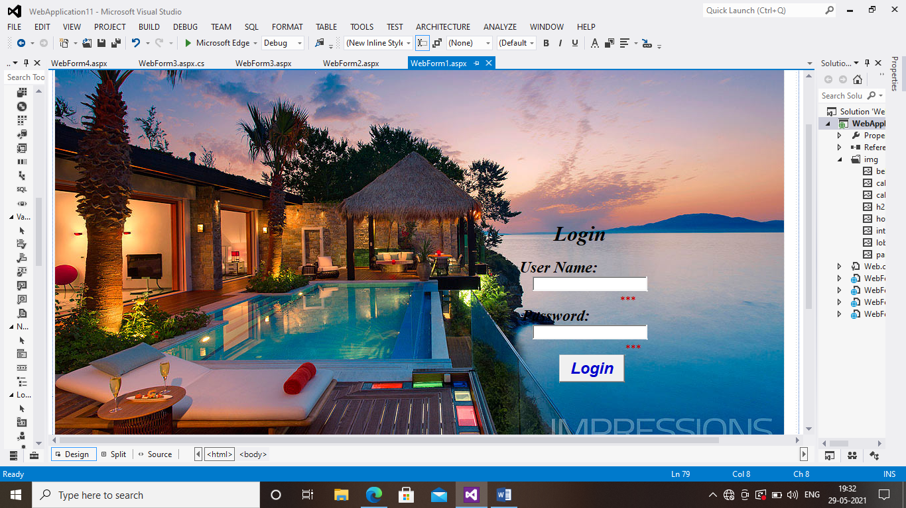

Web Form 2.axpx(SOURCE CODE)

<%@ Page Language="C#" AutoEventWireup="true" CodeBehind="WebForm2.aspx.cs" Inherits="WebApplication11.WebForm2" %>

<!DOCTYPE html>

<html xmlns="http://www.w3.org/1999/xhtml">

<head runat="server">

<title></title>

</head>

<body>

<form id="form1" runat="server">

<div style="height: 528px; background-image: url('img/interior.jpg');">

&nbsp;&nbsp;&nbsp;&nbsp;&nbsp;

<br />

&nbsp;&nbsp;&nbsp;&nbsp;&nbsp;&nbsp;&nbsp;&nbsp;&nbsp;&nbsp;&nbsp;&nbsp;&nbsp;&nbsp;&nbsp;&nbsp;&nbsp;&nbsp;&nbsp;&nbsp;&nbsp;&nbsp;&nbsp;&nbsp;&nbsp;&nbsp;&nbsp;&nbsp;&nbsp;&nbsp;&nbsp;&nbsp;&nbsp;&nbsp;&nbsp;&nbsp;&nbsp;&nbsp;&nbsp;&nbsp;&nbsp;&nbsp;&nbsp;&nbsp;&nbsp;&nbsp;&nbsp;&nbsp;&nbsp;&nbsp;&nbsp;&nbsp;&nbsp;&nbsp;&nbsp;&nbsp;&nbsp;&nbsp;&nbsp;&nbsp;&nbsp;&nbsp;&nbsp;&nbsp;&nbsp;&nbsp;&nbsp;&nbsp;&nbsp;&nbsp;&nbsp;&nbsp;&nbsp;&nbsp;&nbsp;&nbsp;&nbsp;&nbsp;&nbsp;&nbsp;&nbsp;&nbsp;&nbsp;&nbsp;&nbsp;

<asp:Label ID="Label1" runat="server" BackColor="White" Font-Bold="True" Font-Italic="True" Font-Size="XX-Large" style="text-align: center" Text="HOTEL PARADISE"></asp:Label>

<br />

<br />

<br />

<asp:Label ID="Label2" runat="server" Font-Bold="True" Font-Italic="True" Font-Size="X-Large" Text="Reservation Details"></asp:Label>

<br />

<br />

<asp:Label ID="Label3" runat="server" Font-Bold="True" Font-Italic="True" Font-Size="X-Large" Text="Name"></asp:Label>

<br />

&nbsp;&nbsp;&nbsp;&nbsp;&nbsp;&nbsp;

<asp:TextBox ID="TextBox1" runat="server"></asp:TextBox>

&nbsp;

<asp:RequiredFieldValidator ID="RequiredFieldValidator1" runat="server" ControlToValidate="TextBox1" ErrorMessage="*" ForeColor="#CC0000"></asp:RequiredFieldValidator>

<br />

<asp:Label ID="Label4" runat="server" Font-Bold="True" Font-Italic="True" Font-Size="X-Large" Text="Address"></asp:Label>

<br />

&nbsp;&nbsp;&nbsp;&nbsp;&nbsp;&nbsp;

<asp:TextBox ID="TextBox2" runat="server" Height="60px" Width="262px"></asp:TextBox>

<asp:RequiredFieldValidator ID="RequiredFieldValidator2" runat="server" ControlToValidate="TextBox2" ErrorMessage="*" ForeColor="#CC0000"></asp:RequiredFieldValidator>

<br />

<asp:Label ID="Label5" runat="server" Font-Bold="True" Font-Italic="True" Font-Size="X-Large" Text="City"></asp:Label>

<br />

&nbsp;&nbsp;&nbsp;&nbsp;&nbsp;&nbsp;&nbsp;

<asp:DropDownList ID="DropDownList1" runat="server">

<asp:ListItem>---Select---</asp:ListItem>

<asp:ListItem>Mumbai</asp:ListItem>

<asp:ListItem>Delhi</asp:ListItem>

<asp:ListItem>Banglore</asp:ListItem>

<asp:ListItem>Kolkata</asp:ListItem>

<asp:ListItem>Jaipur</asp:ListItem>

<asp:ListItem>Hyderabad</asp:ListItem>

<asp:ListItem>chennai</asp:ListItem>

<asp:ListItem>Pune</asp:ListItem>

<asp:ListItem>Lucknow</asp:ListItem>

<asp:ListItem>Kochi</asp:ListItem>

</asp:DropDownList>

<asp:RequiredFieldValidator ID="RequiredFieldValidator6" runat="server" ControlToValidate="DropDownList1" ErrorMessage="*" ForeColor="#CC0000"></asp:RequiredFieldValidator>

<br />

<asp:Label ID="Label6" runat="server" Font-Bold="True" Font-Italic="True" Font-Size="X-Large" Text="State"></asp:Label>

<br />

&nbsp;&nbsp;&nbsp;&nbsp;&nbsp;&nbsp;

<asp:DropDownList ID="DropDownList2" runat="server">

<asp:ListItem>Uttra pradesh</asp:ListItem>

<asp:ListItem>Maharshtra</asp:ListItem>

<asp:ListItem>karnataka</asp:ListItem>

<asp:ListItem>Kerala</asp:ListItem>

<asp:ListItem>Tamilnadu</asp:ListItem>

<asp:ListItem>Gujrat</asp:ListItem>

<asp:ListItem>Andra pradesh</asp:ListItem>

<asp:ListItem>Rajasthan</asp:ListItem>

<asp:ListItem>Madhya pradesh</asp:ListItem>

<asp:ListItem>Assam</asp:ListItem>

<asp:ListItem>Bihar</asp:ListItem>

</asp:DropDownList>

<asp:RequiredFieldValidator ID="RequiredFieldValidator7" runat="server" ControlToValidate="DropDownList2" ErrorMessage="*" ForeColor="#CC0000"></asp:RequiredFieldValidator>

<br />

<asp:Label ID="Label7" runat="server" Font-Bold="True" Font-Italic="True" Font-Size="X-Large" Text="Zip Code"></asp:Label>

<br />

&nbsp;&nbsp;&nbsp;&nbsp;&nbsp;&nbsp;

<asp:TextBox ID="TextBox5" runat="server"></asp:TextBox>

<asp:RequiredFieldValidator ID="RequiredFieldValidator5" runat="server" ControlToValidate="TextBox5" ErrorMessage="*" ForeColor="#CC0000"></asp:RequiredFieldValidator>

<br />

<br />

&nbsp;&nbsp;&nbsp;&nbsp;&nbsp;&nbsp;

<asp:HyperLink ID="HyperLink1" runat="server" Font-Bold="True" Font-Italic="True" Font-Size="X-Large" ForeColor="#0000CC" NavigateUrl="~/WebForm3.aspx">Next</asp:HyperLink>

<br />

&nbsp;&nbsp;&nbsp;&nbsp;&nbsp;&nbsp;&nbsp;&nbsp;&nbsp;&nbsp;&nbsp;&nbsp;&nbsp;&nbsp;&nbsp;&nbsp;&nbsp;&nbsp;&nbsp;&nbsp;&nbsp;&nbsp;&nbsp;&nbsp;&nbsp;&nbsp;&nbsp;&nbsp;&nbsp;&nbsp;&nbsp;&nbsp;&nbsp;&nbsp;

<br />

&nbsp;&nbsp;&nbsp;&nbsp;&nbsp;&nbsp;&nbsp;&nbsp;&nbsp;&nbsp;&nbsp;&nbsp;&nbsp;&nbsp;&nbsp;&nbsp;&nbsp;&nbsp;&nbsp;

<br />

&nbsp;&nbsp;&nbsp;&nbsp;&nbsp;&nbsp;&nbsp;&nbsp;&nbsp;&nbsp;&nbsp;&nbsp;&nbsp;&nbsp;&nbsp;&nbsp;&nbsp;&nbsp;&nbsp;&nbsp;&nbsp;&nbsp;&nbsp;&nbsp;&nbsp;&nbsp;&nbsp;&nbsp;&nbsp;&nbsp;&nbsp;&nbsp;&nbsp;

<br />

&nbsp;&nbsp;&nbsp;&nbsp;&nbsp;&nbsp;

</div>

</form>

</body>

</html>

WebForm2.aspx(Design page)

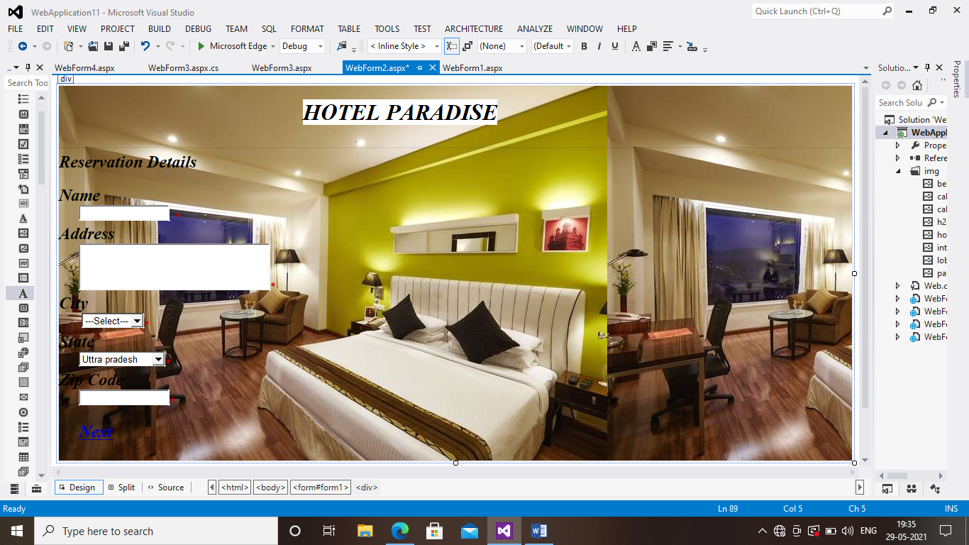

WebForm3.aspx(SOURCE CODE)

<%@ Page Language="C#" AutoEventWireup="true" CodeBehind="WebForm3.aspx.cs" Inherits="WebApplication11.WebForm3" %>

<!DOCTYPE html>

<html xmlns="http://www.w3.org/1999/xhtml">

<head runat="server">

<title></title>

</head>

<body>

<form id="form1" runat="server">

<div style="background-image: url('img/hotel1.jpg')">

<asp:Label ID="Label1" runat="server" Font-Bold="True" Font-Italic="True" Font-Size="X-Large" Text="E-mail Address"></asp:Label>

&nbsp;<asp:RequiredFieldValidator ID="RequiredFieldValidator1" runat="server" ControlToValidate="TextBox1" ErrorMessage="*" ForeColor="#CC0000"></asp:RequiredFieldValidator>

<br />

&nbsp;&nbsp;&nbsp;&nbsp;&nbsp;

<asp:TextBox ID="TextBox1" runat="server"></asp:TextBox>

<br />

<asp:Label ID="Label2" runat="server" Font-Bold="True" Font-Italic="True" Font-Size="X-Large" Text="Check-In date"></asp:Label>

&nbsp;&nbsp;&nbsp;&nbsp;&nbsp;&nbsp;&nbsp;&nbsp;&nbsp;&nbsp;&nbsp;&nbsp;&nbsp;&nbsp;&nbsp;&nbsp;&nbsp;&nbsp;&nbsp;&nbsp;&nbsp;&nbsp;&nbsp;&nbsp;&nbsp;&nbsp;&nbsp;&nbsp;&nbsp;&nbsp;&nbsp;&nbsp;&nbsp;&nbsp;&nbsp;&nbsp;&nbsp;&nbsp;

<asp:Label ID="Label4" runat="server" Font-Bold="True" Font-Italic="True" Font-Size="X-Large" Text="Check-In Time"></asp:Label>

<br />

&nbsp;&nbsp;&nbsp;&nbsp;&nbsp;

<asp:TextBox ID="TextBox2" runat="server"></asp:TextBox>

&nbsp;

<asp:ImageButton ID="ImageButton1" runat="server" Height="26px" ImageUrl="~/img/calender.jpg" OnClick="ImageButton1_Click" />

&nbsp;&nbsp;&nbsp;&nbsp;&nbsp;&nbsp;&nbsp;&nbsp;&nbsp;&nbsp;&nbsp;&nbsp;&nbsp;&nbsp;&nbsp;&nbsp;&nbsp;&nbsp;&nbsp;&nbsp;&nbsp;&nbsp;&nbsp;&nbsp;&nbsp;&nbsp;&nbsp;&nbsp;&nbsp;&nbsp;&nbsp;

<asp:TextBox ID="TextBox4" runat="server"></asp:TextBox>

&nbsp;

<asp:Calendar ID="Calendar1" runat="server" OnSelectionChanged="Calendar1_SelectionChanged"></asp:Calendar>

<br />

<asp:Label ID="Label3" runat="server" Font-Bold="True" Font-Italic="True" Font-Size="X-Large" Text="Check-Out date"></asp:Label>

&nbsp;&nbsp;&nbsp;&nbsp;&nbsp;&nbsp;&nbsp;&nbsp;&nbsp;&nbsp;&nbsp;&nbsp;&nbsp;&nbsp;&nbsp;&nbsp;&nbsp;&nbsp;&nbsp;&nbsp;&nbsp;&nbsp;&nbsp;&nbsp;&nbsp;&nbsp;&nbsp;&nbsp;&nbsp;&nbsp;&nbsp;&nbsp;&nbsp;&nbsp;&nbsp;&nbsp;&nbsp;

<asp:Label ID="Label5" runat="server" Font-Bold="True" Font-Italic="True" Font-Size="X-Large" Text="Check_Out time"></asp:Label>

<br />

&nbsp;&nbsp;&nbsp;&nbsp;&nbsp;&nbsp;

<asp:TextBox ID="TextBox3" runat="server"></asp:TextBox>

&nbsp;<asp:ImageButton ID="ImageButton2" runat="server" Height="23px" ImageUrl="~/img/calender new.png" OnClick="ImageButton2_Click" />

&nbsp;&nbsp;&nbsp;&nbsp;&nbsp;&nbsp;&nbsp;&nbsp;&nbsp;&nbsp;&nbsp;&nbsp;&nbsp;&nbsp;&nbsp;&nbsp;&nbsp;&nbsp;&nbsp;&nbsp;&nbsp;&nbsp;&nbsp;&nbsp;&nbsp;&nbsp;&nbsp;&nbsp;&nbsp;&nbsp;&nbsp;&nbsp;&nbsp;&nbsp;&nbsp;&nbsp;

<asp:TextBox ID="TextBox5" runat="server"></asp:TextBox>

&nbsp;&nbsp;

<asp:Calendar ID="Calendar2" runat="server" OnSelectionChanged="Calendar2_SelectionChanged"></asp:Calendar>

&nbsp;&nbsp;&nbsp;&nbsp;&nbsp;&nbsp;&nbsp;&nbsp;&nbsp;&nbsp;&nbsp;&nbsp;&nbsp;&nbsp;&nbsp;&nbsp;&nbsp;&nbsp;&nbsp;

<br />

<asp:Label ID="Label6" runat="server" Font-Bold="True" Font-Italic="True" Font-Size="X-Large" Text="Room Preference"></asp:Label>

&nbsp;<asp:RadioButton ID="RadioButton1" runat="server" Font-Bold="True" Font-Italic="True" Text="Standard" />

&nbsp;<asp:RadioButton ID="RadioButton2" runat="server" Font-Bold="True" Font-Italic="True" Text="Deluxe" />

&nbsp;<asp:RadioButton ID="RadioButton3" runat="server" Font-Bold="True" Font-Italic="True" Text="Suite" />

&nbsp;&nbsp;&nbsp;&nbsp;

<br />

<br />

<br />

<asp:Button ID="Button1" runat="server" BackColor="#3399FF" Font-Bold="True" Font-Italic="True" Font-Size="Large" PostBackUrl="~/WebForm4.aspx" Text="Submit" />

</div>

</form>

</body>

</html>

WebForm3.aspx(DESIGN PAGE)

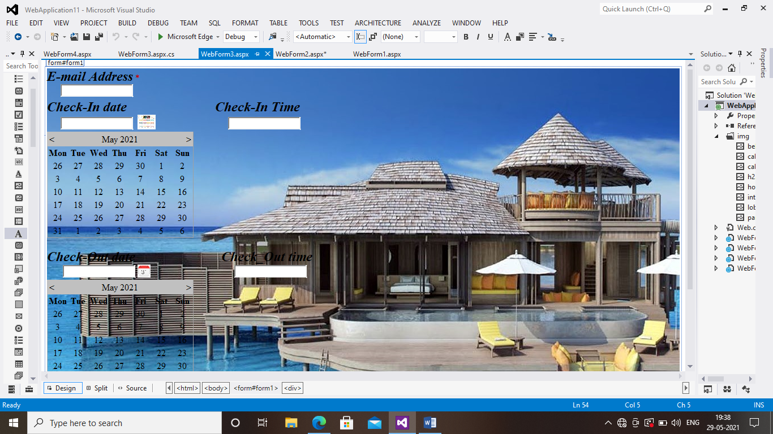

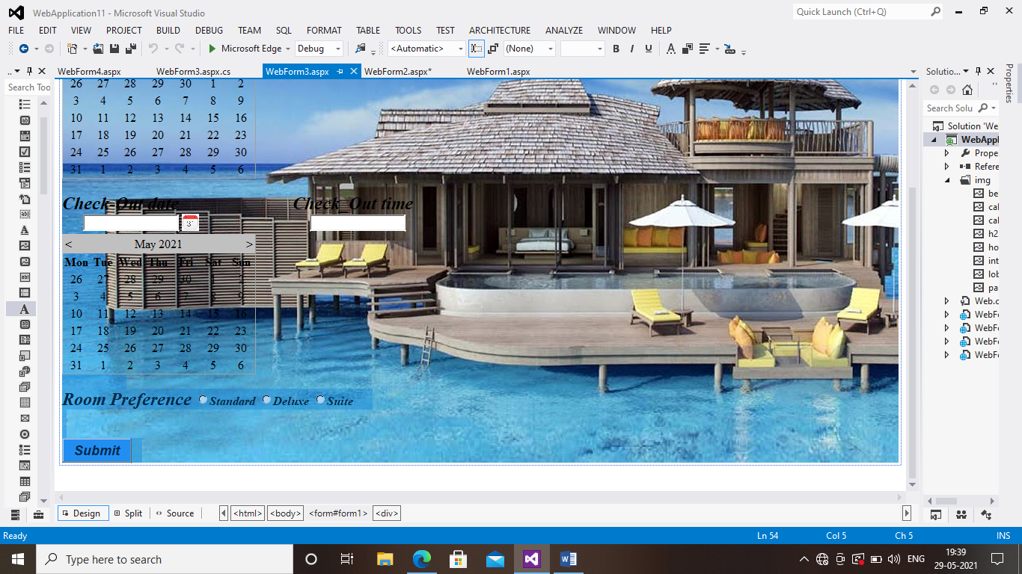

WebForm3.axpx.cs

using System;

using System.Collections.Generic;

using System.Linq;

using System.Web;

using System.Web.UI;

using System.Web.UI.WebControls;

namespace WebApplication11

{

public partial class WebForm3 : System.Web.UI.Page

{

protected void Page_Load(object sender, EventArgs e)

{

if (!IsPostBack)

{

Calendar1.Visible = false;

}

if (!IsPostBack)

{

Calendar2.Visible = false;

}

}

protected void ImageButton1_Click(object sender, ImageClickEventArgs e)

{

Calendar1.Visible = true;

}

protected void Calendar1_SelectionChanged(object sender, EventArgs e)

{

TextBox2.Text = Calendar1.SelectedDate.ToString("d");

Calendar1.Visible = false;

}

protected void ImageButton2_Click(object sender, ImageClickEventArgs e)

{

Calendar2.Visible = true;

}

protected void Calendar2_SelectionChanged(object sender, EventArgs e)

{

TextBox3.Text = Calendar2.SelectedDate.ToString("d");

Calendar2.Visible = false;

}

}

}

WebForm4.aspx(SOURCE CODE)

<%@ Page Language="C#" AutoEventWireup="true" CodeBehind="WebForm4.aspx.cs" Inherits="WebApplication11.WebForm4" %>

<!DOCTYPE html>

<html xmlns="http://www.w3.org/1999/xhtml">

<head runat="server">

<title></title>

</head>

<body style="height: 424px">

<form id="form1" runat="server">

<div style="background-image: url('img/paradise.jpg'); height: 720px; width: 1478px; text-align: justify;">

<br />

<br />

<br />

<br />

<br />

<br />

<br />

<br />

<br />

<br />

<br />

<br />

<br />

<br />

<br />

<br />

<br />

<br />

<br />

<br />

<br />

<br />

<br />

&nbsp;&nbsp;&nbsp;&nbsp;&nbsp;&nbsp;&nbsp;&nbsp;&nbsp;&nbsp;&nbsp;&nbsp;&nbsp;&nbsp;&nbsp;&nbsp;&nbsp;&nbsp;&nbsp;&nbsp;&nbsp;&nbsp;&nbsp;&nbsp;&nbsp;&nbsp;&nbsp;&nbsp;&nbsp;&nbsp;&nbsp;&nbsp;&nbsp;&nbsp;&nbsp;&nbsp;&nbsp;&nbsp;&nbsp;&nbsp;&nbsp;&nbsp;&nbsp;&nbsp;&nbsp;&nbsp;&nbsp;&nbsp;&nbsp;&nbsp;&nbsp;&nbsp;&nbsp;&nbsp;&nbsp;&nbsp;&nbsp;&nbsp;&nbsp;&nbsp;&nbsp;&nbsp;&nbsp;&nbsp;&nbsp;&nbsp;&nbsp;&nbsp;&nbsp;&nbsp;&nbsp;&nbsp;&nbsp;&nbsp;&nbsp;&nbsp;&nbsp;&nbsp;&nbsp;&nbsp;&nbsp;&nbsp;&nbsp;&nbsp;&nbsp;&nbsp;&nbsp;&nbsp;&nbsp;&nbsp;&nbsp;&nbsp;&nbsp;&nbsp;&nbsp;&nbsp;&nbsp;&nbsp;&nbsp;&nbsp;&nbsp;&nbsp;&nbsp;&nbsp;&nbsp;&nbsp;&nbsp;&nbsp;&nbsp;&nbsp;&nbsp;&nbsp;&nbsp;&nbsp;&nbsp;&nbsp;&nbsp;&nbsp;&nbsp;&nbsp;&nbsp;&nbsp;&nbsp;&nbsp;&nbsp;&nbsp;&nbsp;&nbsp;&nbsp;&nbsp;&nbsp;&nbsp;&nbsp;&nbsp;&nbsp;&nbsp;&nbsp;&nbsp;&nbsp;&nbsp;

<asp:ImageButton ID="ImageButton1" runat="server" Height="145px" ImageUrl="~/img/bell.jpg" />

<br />

&nbsp;&nbsp;&nbsp;&nbsp;&nbsp;&nbsp;&nbsp;&nbsp;&nbsp;&nbsp;&nbsp;&nbsp;&nbsp;&nbsp;&nbsp;&nbsp;&nbsp;&nbsp;&nbsp;&nbsp;&nbsp;&nbsp;&nbsp;&nbsp;&nbsp;&nbsp;&nbsp;&nbsp;&nbsp;&nbsp;&nbsp;&nbsp;&nbsp;&nbsp;&nbsp;&nbsp;&nbsp;&nbsp;&nbsp;&nbsp;&nbsp;&nbsp;&nbsp;&nbsp;&nbsp;&nbsp;&nbsp;&nbsp;&nbsp;&nbsp;&nbsp;&nbsp;&nbsp;&nbsp;&nbsp;&nbsp;&nbsp;&nbsp;&nbsp;&nbsp;&nbsp;&nbsp;&nbsp;&nbsp;&nbsp;&nbsp;&nbsp;&nbsp;&nbsp;&nbsp;&nbsp;&nbsp;&nbsp;&nbsp;&nbsp;&nbsp;&nbsp;&nbsp;&nbsp;&nbsp;&nbsp;&nbsp;&nbsp;&nbsp;&nbsp;&nbsp;&nbsp;&nbsp;&nbsp;&nbsp;&nbsp;&nbsp;&nbsp;&nbsp;&nbsp;&nbsp;&nbsp;&nbsp;&nbsp;&nbsp;&nbsp;&nbsp;&nbsp;&nbsp;&nbsp;&nbsp;&nbsp;&nbsp;&nbsp;&nbsp;&nbsp;&nbsp;&nbsp;

<asp:Label ID="Label1" runat="server" BackColor="#3333FF" Font-Bold="True" Font-Italic="True" Font-Size="XX-Large" style="text-align: center" Text="Your Booking is successfull"></asp:Label>

<br />

<br />

&nbsp;&nbsp;&nbsp;&nbsp;&nbsp;&nbsp;&nbsp;&nbsp;&nbsp;&nbsp;&nbsp;&nbsp;&nbsp;&nbsp;&nbsp;&nbsp;&nbsp;&nbsp;&nbsp;&nbsp;&nbsp;&nbsp;&nbsp;&nbsp;&nbsp;&nbsp;&nbsp;&nbsp;&nbsp;&nbsp;&nbsp;&nbsp;&nbsp;&nbsp;&nbsp;&nbsp;&nbsp;&nbsp;&nbsp;&nbsp;&nbsp;&nbsp;&nbsp;&nbsp;&nbsp;&nbsp;&nbsp;&nbsp;&nbsp;&nbsp;&nbsp;&nbsp;&nbsp;&nbsp;&nbsp;&nbsp;&nbsp;&nbsp;&nbsp;&nbsp;&nbsp;&nbsp;&nbsp;&nbsp;&nbsp;&nbsp;&nbsp;&nbsp;&nbsp;&nbsp;&nbsp;&nbsp;&nbsp;&nbsp;&nbsp;&nbsp;&nbsp;&nbsp;&nbsp;&nbsp;&nbsp;&nbsp;&nbsp;&nbsp;&nbsp;&nbsp;&nbsp;&nbsp;&nbsp;&nbsp;&nbsp;&nbsp;&nbsp;&nbsp;&nbsp;&nbsp;&nbsp;&nbsp;&nbsp;&nbsp;&nbsp;&nbsp;&nbsp;&nbsp;&nbsp;&nbsp;&nbsp;&nbsp;&nbsp;&nbsp;&nbsp;&nbsp;&nbsp;&nbsp;&nbsp;&nbsp;&nbsp;&nbsp;&nbsp;&nbsp;&nbsp;&nbsp;&nbsp;&nbsp;&nbsp;&nbsp;&nbsp;&nbsp;&nbsp;&nbsp;&nbsp;&nbsp;&nbsp;&nbsp;&nbsp;&nbsp;&nbsp;&nbsp;&nbsp;&nbsp;&nbsp;&nbsp;&nbsp;&nbsp;&nbsp;&nbsp;&nbsp;&nbsp;&nbsp;&nbsp;&nbsp;&nbsp;

</div>

</form>

</body>

</html>

WebForm4.aspx(DESIGN PAGE)

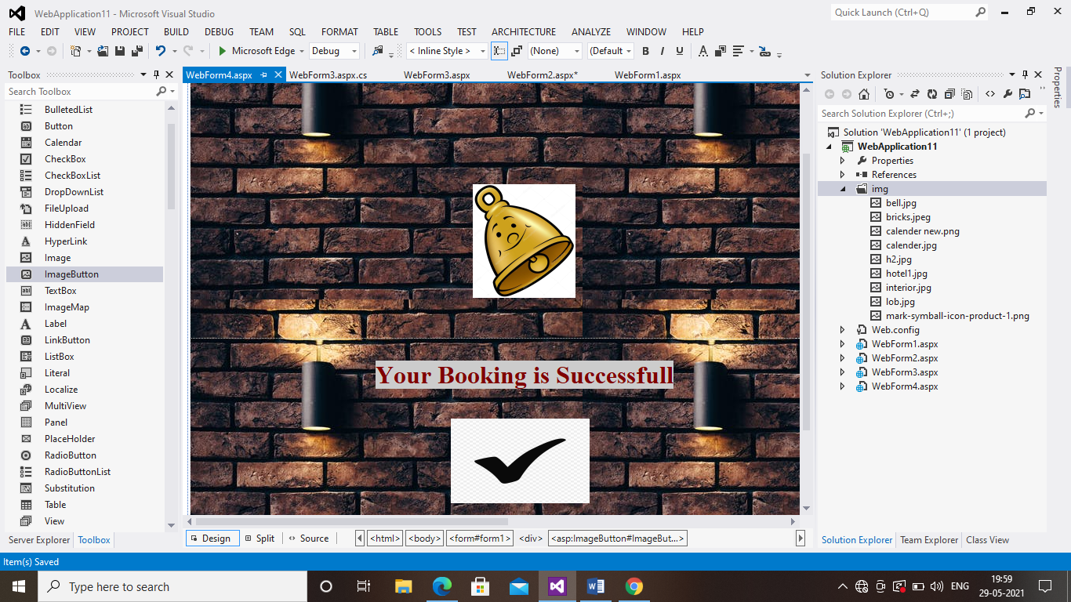

OUTPUT 1:

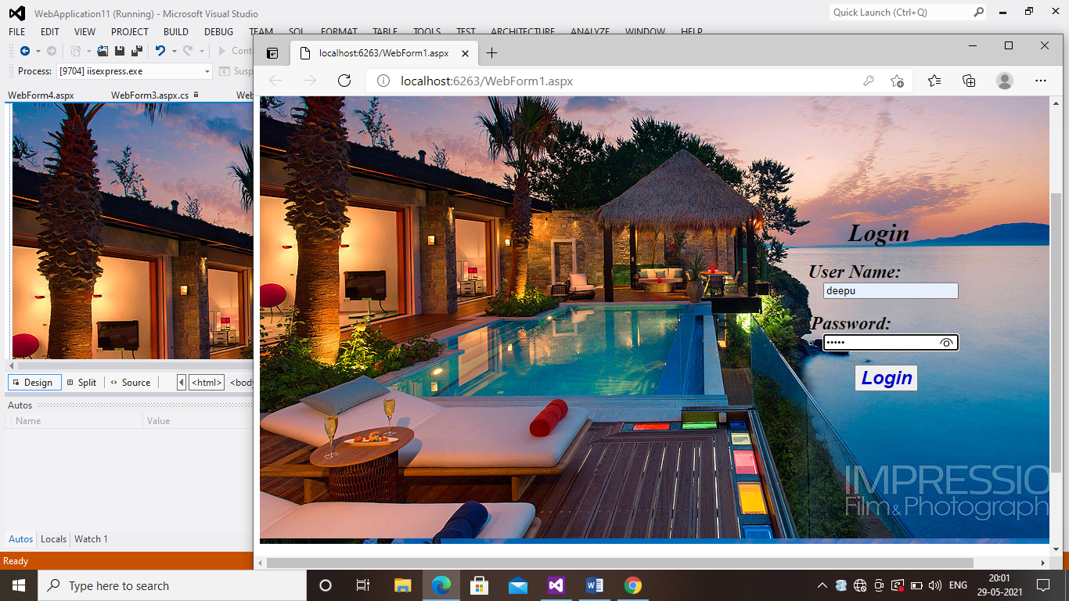

OUTPUT 2:

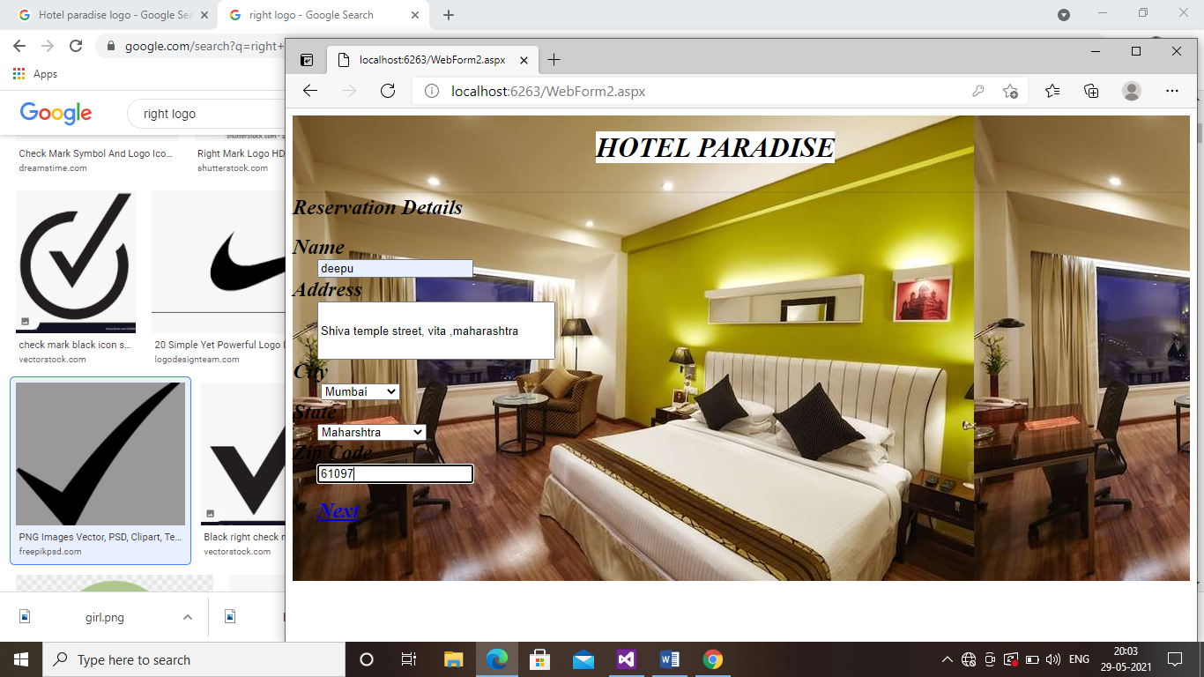

OUTPUT 3:

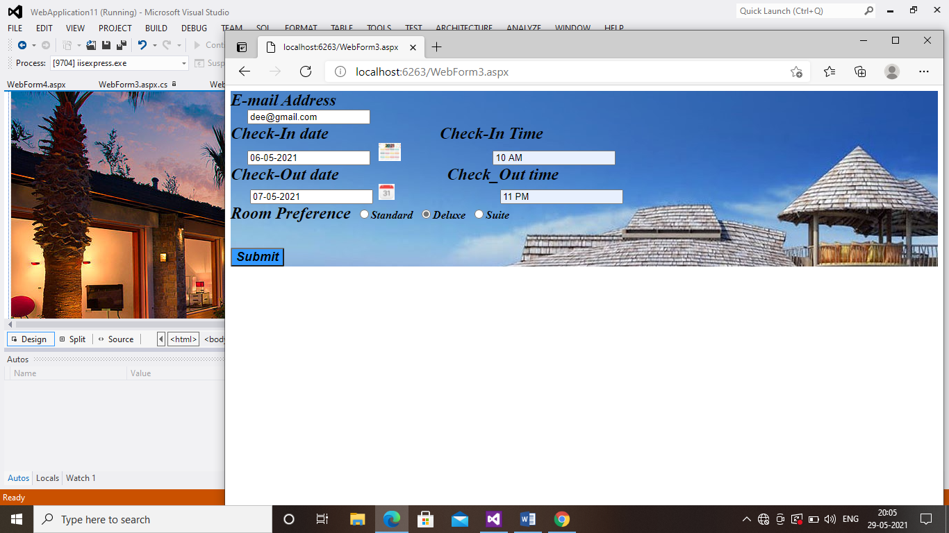

OUTPUT 4:

